

**SLEEP DISORDER PREDICTION**

**SUMMER INTERNSHIP PROJECT REPORT**

***Submitted by***

**PRAVEENKUMAR V (110821205036)**

***in partial fulfilment for the award of the degree***

***of***

**BACHELOR OF TECHNOLOGY**

***in***

**INFORMATION TECHNOLOGY**

**JAYA ENGINEERING COLLEGE, THIRUNINRAVUR**

**ANNA UNIVERSITY :: CHENNAI 600 025**

**JULY 2024**



**ANNA UNIVERSITY :: CHENNAI 600 025**

**BONAFIDE CERTIFICATE**

Certified that this Summer Internship Project report **“SLEEP DISORDER PREDICTION”** is the bonafide work of, **“PRAVEENKUMAR V (110821205036)”** who carried out the project under my supervision.

|  |  |
| --- | --- |
| **SIGNATURE OF** | **SIGNATURE OF** |
| **Dr. SEEDHA DEVI V,**  **Associate Professor,** | **Mr. ALANGARAM S,**  **Assistant Professor,** |
| **HEAD OF THE DEPARTMENT,** | **SUPERVISOR,** |
| Dept. of Information Technology, | Dept. of Information Technology, |
| Jaya Engineering College, | Jaya Engineering College, |
| Thiruninravur-602024, | Thiruninravur-602024, |
| Chennai. | Chennai. |

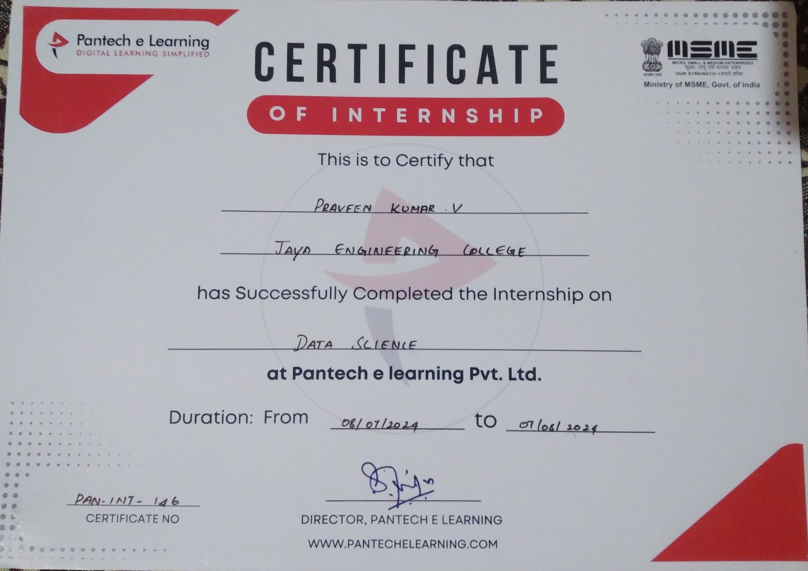

**ABSTRACT**

Sleep disorders affect millions of people worldwide, leading to significant health issues such as cardiovascular diseases, mental health disorders, and impaired cognitive function. Early detection and accurate prediction of sleep disorders are crucial for effective intervention and treatment. This project leverages advanced data science techniques to develop a robust system for predicting sleep disorders using data collected from wearable devices, mobile applications, and clinical assessments. the system integrates data from various sources, including physiological signals (heart rate, respiratory rate, movement), sleep patterns, and user-reported sleep quality, to create a comprehensive dataset. This dataset undergoes rigorous preprocessing, including noise reduction, feature extraction, and normalization, to ensure data quality and consistency. the core of the project involves the application of machine learning algorithms, including decision trees, random forests, support vector machines, and deep learning models such as convolutional neural networks (CNNs) and recurrent neural networks (RNNs). These models are trained on historical sleep data to learn patterns and anomalies associated with various sleep disorders, such as insomnia, sleep apnea, and restless leg syndrome. The purpose behind this article is to share some practicable ideas for your next project, which will not only boost your confidence in data science but also play a critical part in enhancing your skills Understanding data science can be quite confusing at first, but with consistent practice, you’ll start to grasp the various notions and terminologies in the subject.

**Keywords:** Sleep disorders, Prediction system, Data science, Machine learning, Wearable devices, Mobile applications, Clinical assessments, Early detection, Personalized treatment, Sleep patterns, Sleep quality, Data preprocessing, Data normalization.

|  |  |  |
| --- | --- | --- |
|  | **TABLE OF CONTENTS** |  |
| **CHAPTER NO** | **TITLE** | **PAGE NO** |
| **I** | **INTRODUCTION** | **1** |
|  | 1.1 Data Science | 1 |
|  | 1.2 Steps in Data Science project | 2 |
|  | 1.3 Roles and Responsibilities | 2 |
|  | 1.4 Data Science Architecture | 6 |
|  | 1.5 Goals | 7 |
| **II** | **SYSTEM REQUIREMENTS** | **7** |
|  | 2.1 Feasibility Study | 7 |
|  | 2.2 Hardware and Software Requirements | 9 |
| **III** | **SYSTEM DESIGN** | **13** |
|  | 3.1 System Architecture | 13 |
|  | 3.2 Modules | 18 |
| **IV** | **SYSTEM IMPLEMENTATION** | **23** |
|  | 4.1 Sample Codes | 23 |
|  | 4.2 Procedure for Execution | 30 |
| **V** | **CONCLUSION FOR FUTURE**  **ENHANCEMENT** | **31** |
|  | **APPENDICES** |  |
|  | **APPENDIX I** | **34** |
|  | **APPENDIX II** | **45** |

**LIST OF FIGURES**

|  |  |  |
| --- | --- | --- |
| **FIG.NO.** | **TITLE** | **PAGE NO.** |
| 1.1 | Data Science | 1 |
| 1.2 | Fundamentals of Data Architecture to Help Data Science | 5 |
| 3.1 | Flow Diagram for Sleeping Disorder Prediction | 18 |
| 4.1 | Sleep Disorder | 23 |
| A1 | Import and Reads a CSV File | 34 |
| A2 | Checking for Missing Values | 34 |
| A3 | Checking the Number of Unique Values in Each Column | 35 |
| A4 | splitting blood pressure into two columns, dropping the blood pressure column and replacing normal weight with normal in BMI column | 35 |
| A5 | Unique Values from Categorical Columns | 36 |
| A6 | Understanding the Data by plotting its Variables | 36 |
| A7 | Gender and Sleep Disorder | 37 |
| A8 | Effect of Occupation on sleep Disorder | 37 |
| A9 | BMI Category and Sleep Disorder | 38 |
| A10 | Label Encoding for categorical Variables | 38 |
| A11 | Correlation Matrix Heatmap | 39 |
| A12 | Implementing Decision Tree and Training Accuracy | 39 |
| A13 | Decision Tree Model Evaluation | 40 |
| A14 | Confusion Matrix | 40 |
| A15 | Actual Vs Fitted Values for Sleep disorder | 41 |
| A16 | Classification Report | 41 |
| A17 | Random Forest Classifier and Training Accuracy | 42 |
| A18 | Random Forest Classifier Evaluation | 42 |
| A19 | Confusion Matrix Heatmap | 43 |
| A20 | Distribution Plot for Predicted and Actual Values | 43 |
| A21 | Classification Report | 44 |

**LIST OF ABBREVIATIONS**

|  |  |
| --- | --- |
| **ABBREVIATION** | **EXPANSION** |
| AI | Artificial Intelligence |
| ML | Machine Learning |
| DL | Deep Learning |
| NN | Neural Networks |
| RF | Random Forest |
| SVM | Support Vector Machine |
| NUMPY | Numerical Python |
| ETL | Extract Transform Load |
| API | Application Programming Interface |
| IOT | Internet Of Things |
| PHI | Protected Health Organization |
| NOSQL | Not Only SQL |
| SQL | Structured Query Language |
| DBMS | Data Base Management System |
| EDA | Exploratory Data Analysis |
| KNN | K-Nearest Neighbors |
| RNN | Recurrent Neutral Network |
| KPI | Key Performance Indicator |

**CHAPTER I**

**INTRODUCTION**

* 1. **DATA SCIENCE**

Data science involves extracting insights and knowledge from data using various techniques and tools. It combines elements of statistics, computer science, and domain expertise to analyze and interpret complex data.

Data science is a profession that requires a variety of scientific tools, processes, algorithms and knowledge extraction systems that are used to identify meaningful patterns in structured and unstructured data alike if you fancy data science and are eager to get a solid grip on the technology, now is as good a time as ever to hone your skills to comprehend and manage the upcoming challenges facing the profession.

The purpose behind this article is to share some practicable ideas for your next project, which will not only boost your confidence in data science but also play a critical part in enhancing your skills Understanding data science can be quite confusing at first, but with consistent practice, you’ll start to grasp the various notions and terminologies in the subject.

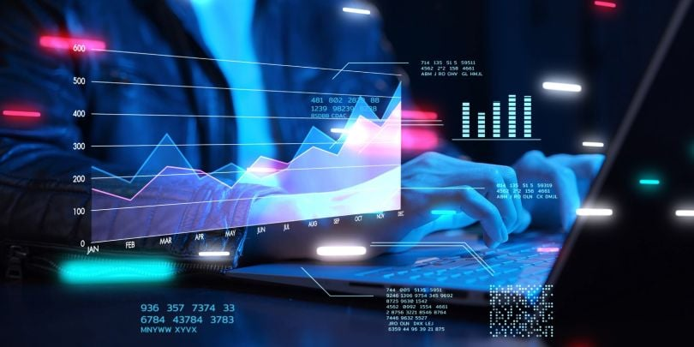The best way to gain more exposure to data science apart from going through the literature is to take on some helpful projects that will up skill you and make your resume more impressive.

*FIG.1.1 Data Science*

**1.2 Steps in data science project**

* **Define the Problem**: Clearly state what you want to solve or understand.
* **Gather and Clean Data**: Collect relevant data and prepare it for analysis by cleaning and organizing it.
* **Explore the Data**: Use statistical methods and visualization tools to understand patterns and relationships.
* **Model the Data**: Apply machine learning algorithms to build predictive models.
* **Evaluate the Mode**l: Assess the model’s performance using appropriate metrics.
* **Communicate Results**: Present your findings in a clear and concise manner, often using visualizations.

**1.3 Roles and Responsibilities**

* In the world of data space, the era of Big Data emerged when organizations are dealing with petabytes and exabytes of data. It became very tough for industries for the storage of data until 2010. Now when the popular frameworks like Hadoop and others solved the problem of storage, the focus is on processing the data. And here Data Science plays a big role. Nowadays the growth of data science has been increased in various ways and one should be ready for the future by learning what data science is and how can we add value to it.
* Data science means different things for different people, but at its gist, data science is using data to answer questions. This definition is a moderately broad definition, and that’s because one must say data science is a moderately broad field.
* “Data science is the science of analyzing raw data using statistics and machine learning techniques with the purpose of drawing conclusions about that information.”

1. **Management:** The Data Scientist plays an insignificant managerial role where he supports the construction of the base of futuristic and technical abilities within the Data and Analytics field in order to assist various planned and continuing data analytics projects.
2. **Analytics:** The Data Scientist represents a scientific role where he plans, implements, and assesses high-level statistical models and strategies for application in the business’s most complex issues. The Data Scientist develops econometric and statistical models for various problems including projections, classification, clustering, pattern analysis, sampling, simulations, and so forth.
3. **Strategy/Design:** The Data Scientist performs a vital role in the advancement of innovative strategies to understand the business’s consumer trends and management as well as ways to solve difficult business problems, for instance, the optimization of product fulfillment and entire profit.
4. **Collaboration:** The role of the Data Scientist is not a solitary role and in this position, he collaborates with superior data scientists to communicate obstacles and findings to relevant stakeholders in an effort to enhance drive business performance and decision-making.
5. **Knowledge:** The Data Scientist also takes leadership to explore different technologies and tools with the vision of creating innovative data-driven insights for the business at the most agile pace feasible. In this situation, the Data Scientist also uses initiative in assessing and utilizing new and enhanced data science methods for the business, which he delivers to senior management of approval.
6. **Other Duties**: A Data Scientist also performs related tasks and tasks as assigned by the Senior Data Scientist, Head of Data Science, Chief Data Officer, or the Employer.

**Advantages of data science:**

In today’s world, data is being generated at an alarming rate. Every second, lots of data is generated; be it from the users of Facebook or any other social networking site, or from the calls that one makes, or the data which is being generated from different organizations. And because of this huge amount of data the value of the field of Data Science has a number of advantages. Some of the advantages are mentioned below:-

* **Multiple Job Options**: Being in demand, it has given rise to a large number of career opportunities in its various fields. Some of them are Data Scientist, Data Analyst, Research Analyst, Business Analyst, Analytics Manager, Big Data Engineer, etc.
* **Business benefits**: Data Science helps organizations knowing how and when their products sell best and that’s why the products are delivered always to the right place and right time. Faster and better decisions are taken by the organization to improve efficiency and earn higher profits.
* **Highly Paid jobs & career opportunities**: As Data Scientist continues being the job and the salaries for this position are also grand. According to a Dice Salary Survey, the annual average salary of a Data Scientist $106,000 per year.
* **Hiring benefits**: It has made it comparatively easier to sort data and look for best of candidates for an organization. Big Data and data mining have made processing and selection of CVs, aptitude tests and games easier for the recruitment teams
* **Informed Decision-Making:** It enables businesses to make data-driven decisions, improving accuracy and outcomes.
* **Predictive Analytics:** Data science allows for the prediction of future trends and behaviors, helping organizations stay ahead of the competition.
* **Personalization:** It enhances customer experiences through personalized recommendations and services.
* **Efficiency Improvement:** Automates processes and optimizes operations, saving time and reducing costs.
* **Risk Management**: Identifies potential risks and fraud, enabling proactive measures to mitigate them.
* **Innovation**: Drives innovation by uncovering hidden patterns and insights in data, leading to new products, services, and strategies.

**Disadvantages of data science**

Everything that comes with a number of benefits also has some consequences.

* **Data Privacy**: Data is the core component that can increase the productivity and the revenue of industry by making game-changing business decisions. But the information or the insights obtained from the data can be misused against any organization or a group of people or any committee etc. Extracted information from the structured as well as unstructured data for further use can also misused against a group of people of a country or some committee**.**
* **Cost:** The tools used for data science and analytics can cost a lot to an organization as some of the tools are complex and require the people.
* **Data Privacy Concerns**: Handling large amounts of data, especially personal data, raises significant privacy issues. Improper handling or breaches can lead to sensitive information being exposed.
* **Bias and Discrimination:** Data science models can inadvertently reinforce existing biases present in the data, leading to unfair or discriminatory outcomes, especially in areas like hiring, lending, and law enforcement.
* **Overfitting and Model Errors**: There's a risk of creating models that perform well on training data but fail in real-world scenarios. Overfitting, where a model learns the noise rather than the signal, can be a major problem**.**
* **Complexity and Interpretability**: Advanced models, like deep learning, can be highly complex and difficult to interpret. This lack of transparency can be problematic, especially in critical applications like healthcare or finance.
* **High Costs and Resources:** Implementing data science solutions often requires significant computational power, specialized skills, and resources, making it expensive for some organizations.
* **Job Displacement**: Automation and optimization driven by data science can lead to job displacement in certain industries, as machines and algorithms can replace tasks previously done by humans.

**1.4 Data science architecture**

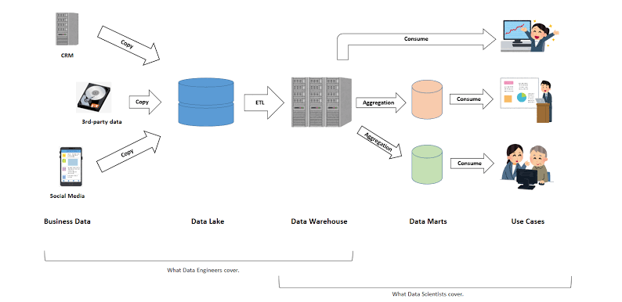*FIG 1.2 Fundamental of Data Architecture To Help Data Scientists*

**1). Business Data Sources**

Data is sourced from CRM systems, third-party data, and social media.

**2). Data Lake**

The raw data is copied into a Data Lake, where it is stored in its original format.

**3). Data Warehouse**

The data from the Data Lake is processed (ETL - Extract, Transform, Load)

4). **Data Marts**

* Moved into a Data Warehouse for structured storage.
* Aggregated data is then placed into Data Marts, which are specialized subsets of the Data Warehouse, tailored for specific business use cases.

**4). Use Cases**

Data Scientists and analysts consume data from the Data Warehouse and Data Marts to generate insights, reports, and visualizations.

**5). Roles**

**Data Engineers**

Handle data ingestion, storage, and processing (Data Lake, Data Warehouse).

**Data Scientists**:

Focus on analysis, modeling, and deriving insights (Data Marts, Use Cases).

**1.5 Goals**

The goals of data science revolve around extracting valuable insights and knowledge from data to support decision-making and drive business outcomes. Key goals include:

* **Data Exploration and Analysis:** Understanding the underlying patterns, trends, and relationships in data.
* **Predictive Modeling:** Building models that predict future outcomes based on historical data.
* **Anomaly Detection:** Identifying unusual patterns or outliers that may indicate fraud, errors, or opportunities.
* **Data-Driven Innovation:** Creating new products, services, or strategies based on insights derived from data.
* **Automation**: Developing automated systems and algorithms that can make decisions or perform tasks without human intervention.
* **Data Visualization and Reporting:** Communicating findings and insights effectively through charts, graphs, and reports to stakeholders.

**CHAPTER II**

**SYSTEM REQUIREMENTS**

**2.1 Feasibility study**

A feasibility study for predicting sleeping disorders using data science techniques involves several key components.

**2.1.1 Objective**

The aim of the study is to evaluate the feasibility of developing a predictive model for sleeping disorders using data science methods.

* **Scope:** Outline the key aspects that will be covered in the study, such as data availability, model development, potential benefits, challenges, and cost implications.
* **Outcome:** Expected findings and recommendations on whether to proceed with the project.

**2.1.2 Background and Introduction**

* **Sleeping Disorders Overview:** Briefly describe common sleeping disorders (e.g., insomnia, sleep apnea, narcolepsy) and their impact on health.
* **Importance of Prediction:** Discuss the importance of early detection and prediction of sleeping disorders for improving treatment outcomes and quality of life.
* **Role of Data Science:** Explain how data science can be used to predict sleeping disorders, including the types of data that could be used (e.g., biometric data, lifestyle factors, genetic data).

**2.1.3 Data Availability and Requirements**

* **Data Sources**: Identify potential sources of data, such as sleep studies, wearable devices (e.g., smartwatches), electronic health records (EHRs), and self-reported surveys.
* **Data Types:** Discuss the types of data needed for analysis (e.g., heart rate, sleep patterns, oxygen levels, movement during sleep).
* **Data Quality:** Evaluate the quality, completeness, and granularity of available data.
* **Data Privacy and Ethics:** Address ethical considerations, such as data privacy, consent, and anonymization of sensitive information.

**2.1.4 Technical Feasibility**

* **Modeling Techniques:** Explore suitable data science techniques for prediction, such as machine learning algorithms (e.g., random forests, neural networks, support vector machines).
* **Feature Engineering:** Discuss the features that could be relevant in predicting sleeping disorders (e.g., duration of sleep, variability in sleep patterns, comorbid conditions).
* **Tools and Technologies:** Identify the software tools, programming languages, and frameworks that could be used for model development (e.g., Python, R, TensorFlow, Scikit-learn).
* **Computational Requirements:** Assess the computational resources required for data processing, model training, and validation.

**2.1.5 Market and Stakeholder Analysis**

* **Target Audience:** Identify the primary stakeholders, such as healthcare providers, patients, and insurance companies.
* **Demand Analysis:** Evaluate the potential demand for predictive tools in sleep medicine.
* **Competition:** Analyze existing solutions and how your predictive model would differ or improve upon them.

**2.1.6 Cost-Benefit Analysis**

* **Development Costs:** Estimate the costs associated with data collection, model development, validation, and deployment.
* **Benefits:** Discuss the potential benefits, such as improved patient outcomes, reduced healthcare costs, and market opportunities.
* **Return on Investment (ROI):** Evaluate the potential ROI by comparing the benefits against the costs.

**2.1.7 Risk Analysis**

* **Technical Risks**: Identify risks associated with data quality, model accuracy, and algorithmic bias.
* **Operational Risks:** Consider risks related to data privacy breaches, compliance with regulations (e.g., GDPR, HIPAA).
* **Market Risks:** Assess risks related to market adoption, competition.

**2.1.8 Regulatory and Compliance Considerations**

* **Regulatory Requirements**: Discuss the regulatory environment relevant to data collection and analysis in healthcare.
* **Compliance**: Ensure that the predictive model adheres to relevant laws and guidelines (e.g., FDA regulations for medical devices, privacy laws).

**2.1.9 Pilot Study Proposal**

* **Pilot Objectives:** Define the goals of a pilot study to test the feasibility of the predictive model.
* **Methodology**: Outline the steps for conducting a pilot study, including data collection, model training, and evaluation.
* **Evaluation Metrics:** Identify key performance indicators (KPIs) for success, such as model accuracy, sensitivity, specificity, and user satisfaction.

**2.2 Hardware and Software Requirements**

When designing a system for predicting sleeping disorders using data science, both hardware and software requirements must be carefully considered to ensure efficient data processing, model training, and deployment. Below is a detailed overview of the hardware and software requirements.

**2.2.1 Hardware Requirements**

**1.Data Collection Devices**

- Wearable Devices: Devices like smartwatches or fitness trackers (e.g., Fitbit, Apple Watch) to collect biometric data such as heart rate, sleep duration, movement, and oxygen levels.

- Polysomnography Equipment: For detailed sleep studies, specialized equipment to measure brain waves, blood oxygen levels, heart rate, and breathing during sleep.

- Mobile Devices: Smartphones or tablets to collect and transmit data from wearables or user inputs.

**2.Data Storage**

**Local Storage**

- Hard Drives/SSDs: Sufficient storage space for local data processing and backup.

- Network Attached Storage (NAS): For larger data storage and easy access within a local network.

**Cloud Storage**

- Cloud Platforms: Use of cloud services like AWS S3, Google Cloud Storage, or Azure Blob Storage for scalable and secure data storage.

**3. Computing Infrastructure**

**Local Workstations**

- High-Performance CPUs: Multi-core processors (e.g., Intel Core i9, AMD Ryzen 9) for faster data processing.

- GPUs: Dedicated GPUs (e.g., NVIDIA RTX series) for accelerating machine learning model training, particularly deep learning models.

- RAM: 32 GB or higher to handle large datasets and complex computations.

**Server Infrastructure**

- High-Performance Servers: Servers equipped with multiple CPUs/GPUs for parallel processing and handling large-scale data.

- Cluster Computing: For large projects, a cluster of computers with distributed computing capabilities (e.g., Apache Hadoop, Apache Spark).

**Cloud Computing**

- Cloud Services: Use of cloud-based computing resources (e.g., AWS EC2, Google Cloud Compute, Microsoft Azure) for scalable processing power and storage.

**4. Networking**

- High-Speed Internet: Reliable and fast internet connection for data transfer between devices and cloud servers.

- Secure VPN: For secure remote access to the computing infrastructure and data.

**2.2.2 Software Requirements**

**1.Data Collection and Preprocessing**

- APIs for Wearables: Software development kits (SDKs) and APIs provided by wearable device manufacturers (e.g., Fitbit SDK, Apple HealthKit) for data collection.

- Data Integration Tools Tools like Apache NiFi or Talend for integrating data from various sources.

- Data Cleaning Tools: Python libraries (e.g., Pandas, NumPy) or R packages for preprocessing and cleaning raw data.

**2. Data Management**

**Database Systems**

- Relational Databases: MySQL, PostgreSQL for structured data storage.

NoSQL Databases: MongoDB, Cassandra for unstructured or semi-structured data.

- Data Warehousing: Tools like Amazon Redshift, Google BigQuery for managing large volumes of data.

**3.Machine Learning and Data Science**

**Programming Languages**

- Python: Widely used in data science with libraries like TensorFlow, Keras, Scikit-learn for machine learning.

- R: Another popular language for statistical analysis and machine learning.

**Data Science Libraries**

- TensorFlow/PyTorch: For building and training deep learning models.

- Scikit-learn: For traditional machine learning algorithms.

- XGBoost/LightGBM: For gradient boosting models, often used in predictive modeling.

**Statistical Analysis Tools**

- R/RStudio: For advanced statistical analysis and visualization.

- SPSS/SAS: For comprehensive data analysis in research settings.

**Integrated Development Environments (IDEs)**

- Jupyter Notebook: For interactive data exploration and model development.

- PyCharm/VSCode: For more extensive Python development.

- RStudio: For R-based data science projects.

**4.Data Visualization**

**Visualization Libraries**

- Matplotlib/Seaborn: For creating static, publication-quality visualizations in Python.

- Plotly/Dash: For creating interactive dashboards and visualizations.

- Tableau/Power BI: For business intelligence and interactive reporting.

**5.Deployment and Monitoring**

**Model Deployment Tools**

- Flask/Django: For deploying machine learning models as web applications.

TensorFlow Serving: For serving TensorFlow models in production.

- Docker: For containerizing applications and ensuring consistency across environments.

- Kubernetes: For managing containerized applications in a cluster, providing scalability and reliability.

**Monitoring and Logging**

- Prometheus/Grafana: For monitoring application performance and resource usage.

- ELK Stack (Elasticsearch, Logstash, Kibana): For centralized logging and real-time monitoring.

- ML flow: For tracking experiments, model performance, and deployment.

**6.Security**

- Encryption Software: Tools for encrypting sensitive data both at rest and in transit (e.g., OpenSSL, AWS KMS).

**Access Management**

- IAM (Identity and Access Management): For managing access to cloud resources (e.g., AWS IAM, Azure AD).

- Authentication Protocols: Implementing secure authentication mechanisms (e.g., OAuth2, JWT).

**7.Project Management and Collaboration**

- Version Control: Git/GitHub for version control and collaboration among team members.

- Project Management Tools: Jira, Trello, or Asana for managing tasks, sprints, and milestones.

- Collaboration Tools: Slack, Microsoft Teams for team communication and file sharing.

**8.Additional Considerations**

- Compliance Software: Tools that help ensure compliance with data privacy regulations like GDPR and HIPAA.

- Licensing: Ensure all software tools and libraries used are properly licensed for commercial use, especially in healthcare-related projects.

- This combination of hardware and software will provide a robust foundation for developing, deploying, and maintaining a data science project aimed at predicting sleeping disorders.

**CHAPTER III**

**SYSTEM DESIGN**

**3.1 SYSTEM ARCHITECTURE**

The system architecture for predicting sleeping disorders using data science integrates various components, each handling a specific aspect of data collection, processing, analysis, and delivery. Below is a detailed architecture breakdown:

**3.1.1 Architecture Overview**

The architecture is divided into five main layers:

1. Data Collection Layer

2. Data Ingestion and Storage Layer

3. Data Processing and Feature Engineering Layer

4. Machine Learning and Model Management Layer

5. Application and User Interface Layer

6. Monitoring and Security Layer

**3.1.1.2 Detailed Architecture Components**

**1. Data Collection Layer**

**Purpose**

To gather raw data related to sleep patterns from various sources.

**Components**

- Wearable Devices:Collect biometric data such as heart rate, sleep duration, and movement (e.g., Fitbit, Apple Watch).

- Mobile Applications: Collect user-reported data such as sleep habits, daily routines, and symptoms**.**

-Clinical Equipment: Gather high-resolution data from devices like polysomnography machines during clinical sleep studies.

- APIs: Integrate with third-party health data providers (e.g., Google Fit, Apple HealthKit).

**Data Flow**

1. Data is collected by wearable devices and mobile apps.

2. Data is sent to the cloud using secure RESTful APIs.

**2. Data Ingestion and Storage Layer**

**Purpose**

To ingest, store, and manage the raw and processed data.

**Components**

**Data Ingestion Pipeline**

- Stream Processing:Use tools like Apache Kafka or AWS Kinesis for real-time data ingestion**.**

- Batch ProcessingUtilize Apache NiFi or Apache Airflow for scheduled data collection and ETL (Extract, Transform, Load) processes.

- Data Lake:Store raw data in a scalable data lake using cloud storage services like AWS S3, Google Cloud Storage, or Azure Blob Storage.

**Database Systems**

**-** Relational Databases (e.g., PostgreSQL):Store structured data for easy querying and analysis.

- NoSQL Databases (e.g., MongoDB, Cassandra):Store unstructured or semi-structured data, such as logs or sensor data.

**Data Flow**

1. Raw data is ingested into the system via stream or batch processing.

2. Data is stored in the data lake for raw storage, or in structured databases after initial processing.

**3. Data Processing and Feature Engineering Layer**

**Purpose**

To clean, process, and transform raw data into meaningful features for analysis.

**Components**

**Data Processing Framework**

- ETL Tools:Use Apache Spark or custom Python scripts for data cleaning, transformation, and loading**.**

**-** Data Preprocessing: Clean and normalize data to handle missing values, outliers, and inconsistencies.

**Feature Engineering**

- Time-Series Analysis: Derive features like sleep duration, sleep variability, and irregularities.

- Anomaly Detection: Identify patterns that deviate from normal behavior, indicating potential sleep disorders**.**

- Data Warehouse: Store the processed and feature-engineered data for efficient querying and model training (e.g., Amazon Redshift, Google BigQuery).

**Data Flow**

1. Raw data is processed and cleaned through the ETL pipeline.

2. Feature engineering extracts key metrics and insights, which are then stored in the data warehouse for model training**.**

**4. Machine Learning and Model Management Layer**

**Purpose**

To build, train, validate, deploy, and monitor machine learning models.

**Components**

**Model Development**

- Machine Learning Libraries:Use TensorFlow, PyTorch, or Scikit-learn for building and training models.

- Feature Selection: Use techniques like feature importance and PCA (Principal Component Analysis) to select the most relevant features.

**Model Training and Validation**

- Training Pipelines: Automated training pipelines using frameworks like MLflow or Kubeflow.

- Validation: Cross-validation and hyperparameter tuning to optimize model performance.

**Model Deployment**

- Model Serving:Deploy models using TensorFlow Serving or Dockerized RESTful APIs (Flask/Django).

- Model Management: Use tools like MLflow for versioning, experiment tracking, and deployment management.

- Real-Time Inference: Enable real-time predictions using streaming data from wearables and mobile apps.

**Data Flow**

1. Processed data is fed into the machine learning models for training and validation.

2. The trained model is deployed and integrated with the user-facing applications for real-time predictions.

**5. Application and User Interface Layer**

**Purpose**

To provide users with access to predictions, insights, and reports through a UI .

**Components**

**Web/Mobile Applications**

- Frontend Frameworks: Use React.js, Angular, or Flutter for building interactive user interfaces**.**

- Backend Services: Handle user requests and interface with the machine learning models and databases**.**

**Visualization and Reporting**

- Visualization Libraries: D3.js, Plotly, or Chart.js for displaying data insights and predictions.

- Dashboards: Create dashboards for users and healthcare providers to monitor sleep patterns and disorder risks.

- APIs:Provide RESTful or GraphQL APIs for external applications to access prediction services.

**Data Flow**

1. Users input data via the application, which is sent to the backend for processing.

2. Predictions and insights are generated and displayed through the application interface.

**6. Monitoring and Security Layer**

**Purpose**

To ensure the system operates reliably, securely with regulations.

**Components**

**System Monitoring**

- Performance Monitoring: Tools like Prometheus and Grafana to monitor system performance, latency, and resource usage.

- Log Management: Use the ELK Stack (Elasticsearch, Logstash, Kibana) for centralized logging and analysis.

- Model Monitoring: Track model accuracy, detect drift, and retrain models as necessary using tools like MLflow or custom scripts.

**Security and Compliance**

- Data Encryption: Ensure all data is encrypted in transit (TLS/SSL) and at rest (AES-256).

- Access Control: Implement role-based access control (RBAC) using AWS IAM, Azure AD, or similar.

- Audit and Compliance: Regularly audit the system to ensure compliance with regulations like HIPAA and GDPR.

**Data Flow**

1. Continuous monitoring of system performance and security.

2. Alerts and logs are analyzed to detect and respond to issues in real-time.

**3.1.2 Data Flow**

**1. Data Collection**: Data from wearables, mobile apps, and clinical devices is collected and sent to the cloud.

**2. Data Ingestion:** The data ingestion pipeline processes this data in real-time or in batches and stores it in the data lake**.**

**3. Data Processing**: Raw data is cleaned and transformed into usable features, which are stored in the data warehouse**.**

**4. Model Training**: Feature-engineered data is used to train machine learning models.

**5. Prediction**: Trained models provide real-time predictions, which are accessed by users via the web/mobile application**.**

**6. Monitoring**: The system is continuously monitored to ensure reliability, accuracy, and security**.**

**3.1.3. Key Considerations**

**Scalability**: Design the architecture to be scalable, with the ability to handle increasing amounts of data and users.

**Security**: Prioritize data security, especially given the sensitive nature of health data.

**Compliance:** Ensure the system complies with healthcare regulations and data protection laws.

**Flexibility**:

* The architecture should be flexible enough to incorporate new data sources, features, and machine learning models as needed.
* This system architecture provides a comprehensive framework for developing, deploying, and maintaining a data science project focused on predicting sleeping disorders.
* It ensures data integrity, model accuracy, and a seamless user experience.

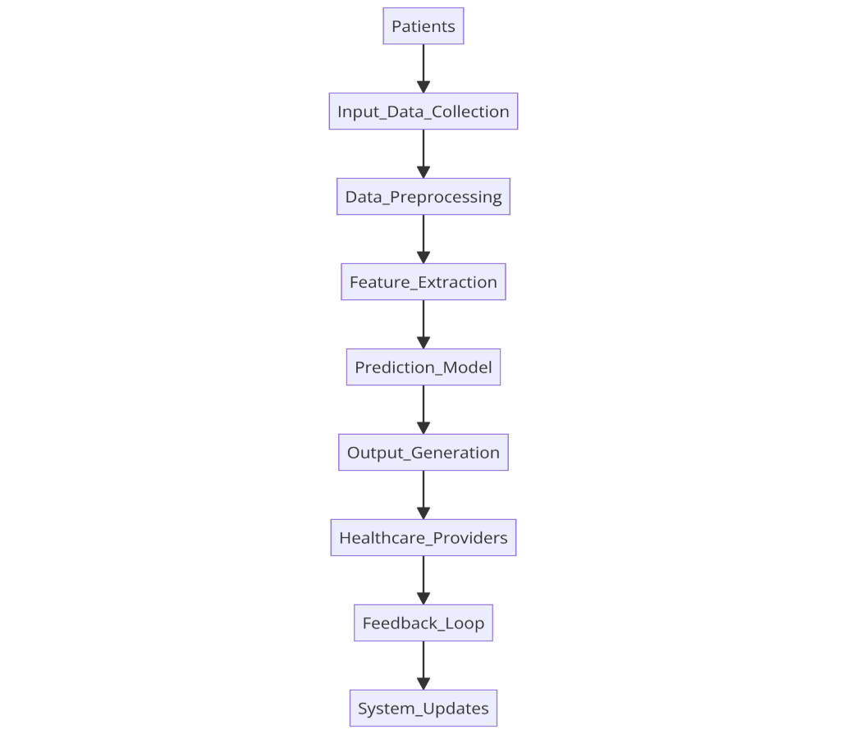

*FIG 3.1 Flow Diagram For Sleeping Disorder Prediction*

**3.2 Modules**

In a sleep disorder prediction project using data science, the system is typically divided into several modules, each responsible for a specific aspect of the project. Below are the key modules you might find in such a project:

1. Data Collection Module
2. Data ingestion module
3. Data storage module
4. Data processing module
5. Feature engineering module
6. Machine learning module
7. Model validation and testing module
8. Model deployment module
9. User interface module
10. Monitoring feedback module
11. Security and compliance module
12. Reporting module

**1.Data collection module**

The data collection module is the foundational phase of the sleep disorder prediction project, where raw data is gathered from various sources to feed into the analysis and prediction pipeline.

This module focuses on acquiring comprehensive and high-quality data that accurately reflects the sleep patterns and physiological signals of users.

Primary data sources include wearable devices such as smartwatches and fitness trackers, which monitor key physiological parameters like heart rate, movement, and oxygen saturation during sleep.

**2. Data Ingestion Module**

The data ingestion module is a crucial stage in the sleep disorder prediction project, where raw data collected from various sources is systematically imported, processed, and prepared for analysis.

This module acts as a bridge between data collection and data processing, ensuring that the vast and diverse datasets are efficiently funneled into the system’s analytical pipeline.

Data ingestion begins with automating the import of data from different sources, such as wearable devices, mobile applications, and clinical databases. This process may involve handling multiple data formats (e.g., JSON, CSV, XML) and establishing connections to data streams or APIs provided by wearable device manufacturers or healthcare platforms.

**3. Data Storage Module**

The data storage module is essential in the sleep disorder prediction project, providing a secure and scalable infrastructure for managing vast amounts of data from various sources.

This module ensures that all data—ranging from structured, like time-series data from wearables, to unstructured, like user-reported sleep quality—is efficiently stored and readily accessible for analysis.

To accommodate different data types, the storage solution typically integrates both relational databases for structured data and NoSQL databases or data lakes for semi-structured or unstructured data.

**4. Data Preprocessing Module**

The data preprocessing module is a critical step in the sleep disorder prediction project, transforming raw data into a clean and structured format suitable for analysis.

This module handles various tasks such as data cleaning, normalization, feature extraction, and transformation, ensuring that the data fed into the machine learning models is accurate and consistent.

**5. Feature Engineering Module**

The feature engineering module plays a pivotal role in the sleep disorder prediction project by enhancing the predictive power of machine learning models. This module involves the process of selecting, transforming, and creating new features from the raw data, which can significantly improve the model's ability to detect patterns and anomalies associated with sleep disorders.

Initially, the module focuses on feature selection identifying the most relevant features from the dataset that have the greatest impact on predicting sleep disorders. These may include metrics like sleep duration, heart rate variability, breathing patterns, and movement during sleep. By filtering out less informative features, the module helps reduce the dimensionality of the dataset, which can lead to more efficient model training and improved performance.

**6. Machine Learning Module**

The machine learning module is the core of the sleep disorder prediction project, where advanced algorithms are employed to analyze processed data and generate predictions about potential sleep disorders. This module leverages a variety of machine learning techniques, including supervised, unsupervised, and deep learning models, to identify patterns and relationships within the data that may indicate sleep disturbances.

Model selection is a critical first step, where the most appropriate algorithms are chosen based on the nature of the data and the specific prediction goals. Commonly used models include decision trees, random forests, support vector machines (SVMs), and deep learning models such as convolutional neural networks (CNNs) and recurrent neural networks (RNNs), which are particularly effective in handling time-series data like sleep patterns.

**7. Model Validation and Testing Module**

The model validation and testing module is a critical component of the sleep disorder prediction project, ensuring that the machine learning models developed are accurate, reliable, and generalizable.

This module rigorously evaluates the performance of the models on data that was not used during the training phase, providing an objective measure of their predictive capabilities.

**8. Model Deployment Module**

The model deployment module is the final stage of the sleep disorder prediction project, where the validated machine learning model is transitioned from a development environment to a production setting.

This module is responsible for making the model accessible to end-users, enabling real-time predictions and integration with other systems such as mobile applications, wearable devices, and healthcare platforms.

**9. User Interface Module**

The user interface (UI) module is a critical component of the sleep disorder prediction project, serving as the primary point of interaction between the users and the system. This module is designed to provide an intuitive, user-friendly platform that allows users—whether they are patients, healthcare providers, or researchers—to easily access, interpret, and act on the predictions and insights generated by the machine learning models.

The UI module is responsible for presenting complex data and predictions in a clear and accessible manner. This often involves the use of data visualization tools such as graphs, charts, and dashboards that display sleep patterns, predicted sleep disorders, and other relevant metrics.

**10. Monitoring and Feedback Module**

The monitoring and feedback module is an essential part of the sleep disorder prediction project, responsible for continuously overseeing the performance of the deployed system and gathering user feedback to enhance its effectiveness.

This module ensures that the system remains accurate, reliable, and responsive to user needs over time. In the monitoring aspect, the module tracks key performance indicators (KPIs) such as prediction accuracy, system response times, and user engagement levels.

**11. Security and Compliance Module**

The security and compliance module is a fundamental part of the sleep disorder prediction project, ensuring that all aspects of the system adhere to strict standards of data protection, privacy, and regulatory compliance.

This module safeguards the sensitive health data handled by the system, which includes personal sleep patterns, biometric information, and other private user details.At the heart of this module is data security, which involves implementing robust encryption m Secure authentication protocols, such as Multi-Factor Authentication

**12. Reporting Module**

This module is crucial for summarizing and communicating insights derived from the data analysis. This module typically involves generating comprehensive reports that outline the findings, trends, and patterns identified in the sleep data.

It includes visualizations such as graphs and charts to illustrate key metrics, such as sleep duration, quality, and patterns of disturbances. The reporting module also provides interpretations of the data, highlighting significant correlations or anomalies related to sleep disorders.

It is designed to offer actionable recommendations for improving sleep health based on the analyzed data, and to facilitate clear communication of results to stakeholders, such as healthcare providers or research teams.

- These modules work together to create a comprehensive system for predicting sleep disorders, ensuring that data is collected, processed, and analyzed effectively, and that users receive accurate and timely predictions**.**

**CHAPTER IV**

**SYSTEM IMPLEMENTION**

**4.1 sample output**

**4.1.1 Sleep Disorder Prediction**

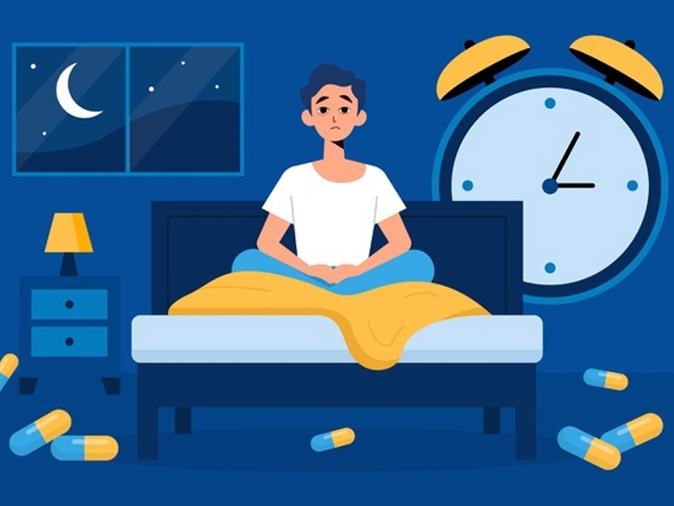

*Fig 4.1 sleep disorder*

The aim of the sleep disorder prediction project is to accurately identify and predict potential sleep disorders in individuals by analyzing data collected from wearable devices, mobile apps, and clinical equipment. This project seeks to provide early detection and insights into sleep health, enabling users and healthcare providers to take proactive measures for diagnosis, treatment, and improved sleep management.

**4.1.2 Data prediction**

In [1]: #importing the libraries

import numpy as np

import pandas as pd

import matplotlib.pyplot as plt

import seaborn as sns

1. **pandas**: A library for data manipulation and analysis, providing DataFrames for handling structured data.

**2.** **numpy:** A library for numerical operations, offering support for arrays and mathematical functions.

**3. matplotlib.pyplot:** A module for creating static plots and visualizations.

**4. seaborn:** A library for statistical data visualization, built on matplotlib, with enhanced aesthetics and easier plotting of complex data

In [2]: #loading the dataset

df = pd.read_csv('Sleep_health_and_lifestyle_dataset.csv')

df.head()

*Reads an Excel file named "crop yield data sheet.xlsx" into a DataFrame called df.

*Displays the first few rows of the DataFrame df, giving a quick preview of the data.

**4.1.3 Data preprocessing (part 1)**

In [3]: #checking for missing values

df.isnull().sum()

# replacing the null values with 'None' in the column 'Sleep Disorder'

df['Sleep Disorder'].fillna('None', inplace=True)

The nan/None value in sleep disorder stands for no sleep disorder, so it is not a missing value

In [4]: #drop column Person ID

df.drop('Person ID', axis=1, inplace=True)

#checking the number of unique values in each column

print("Unique values in each column are:")

for col in df.columns

print(col,df[col].nunique())

Splitting the blood pressure into systolic and diastolic

In [5]: #spliting the blood pressure into two columns

df['systolic_bp'] = df['Blood Pressure'].apply(lambda x: x.split('/')[0])

df['diastolic_bp'] = df['Blood Pressure'].apply(lambda x: x.split('/')[1])

#droping the blood pressure column

df.drop('Blood Pressure', axis=1, inplace=True)

In [6]: #replacing normal weight with normal in BMI column

df['BMI Category'] = df['BMI Category'].replace('Normal Weight', 'Normal')

In [7]: df.head()

Checking the unique values from each categorical column

In [8]: #unique values from categorical columns

print(df.Occupation.unique())

print('\n')

print(df['BMI Category'].unique())

print('\n')

print(df['Sleep Disorder'].unique())

**4.1.4 Explorative Data Analysis**

The EDA is divided into two phases:

Phase 1:

Understanding the data by plotting its variables

Phase 2:

Understanding the correlation between the variables

**Phase 1**

In [9] fig,ax = plt.subplots(3,3,figsize=(20,10))

sns.countplot(x = 'Gender', data = df, ax = ax[0,0])

sns.histplot(x = 'Age', data = df, ax = ax[0,1], bins = 10)

sns.histplot(x = 'Sleep Duration', data = df, ax = ax[0,2], bins = 10)

sns.countplot(x = 'Quality of Sleep', data = df, ax = ax[1,0])

sns.histplot(x = 'Physical Activity Level', data = df, ax = ax[1,1], bins = 10)

sns.countplot(x = 'Stress Level', data = df, ax = ax[1,2])

sns.countplot(x = 'BMI Category', data = df, ax = ax[2,0])

sns.histplot(x = 'Daily Steps', data = df, ax = ax[2,1], bins = 10)

sns.countplot(x = 'Sleep Disorder', data = df, ax = ax[2,2])

The number of males and females is almost equal, out of which majority of the people have age between 30-45 years. Most of the people have sleep quality greater than 5 which means there are getting sufficient sleep.

**Phase 2**

**Gender and Sleep Disorder**

In [10]: #Gender count plot

sns.countplot(x = 'Gender', data = df, palette = 'hls', hue = 'Sleep Disorder').set_title('Gender and Sleep Disorder')

Text(0.5, 1.0, 'Gender and Sleep Disorder')

Most of the males and females are not suffering from any sleep disorder. However females tend to have more sleep disorder as compared to males. The number of females suffering from Sleep Apnea is quite high as compared to males. But in contrast to that, greater number of males are suffering from Insomia as compared to females.

**4.1.5 Effect of Occupation on Sleep Disorder**

In [11] ax = sns.countplot(x = 'Occupation', data = df, hue = 'Sleep Disorder')

ax.set_xticklabels(ax.get_xticklabels(), rotation = 90)

[Text(0, 0, 'Software Engineer'),

Text(1, 0, 'Doctor'),

Text(2, 0, 'Sales Representative'),

Text(3, 0, 'Teacher'),

Text(4, 0, 'Nurse'),

Text(5, 0, 'Engineer'),

Text(6, 0, 'Accountant'),

Text(7, 0, 'Scientist'),

Text(8, 0, 'Lawyer'),

Text(9, 0, 'Salesperson'),

Text(10, 0, 'Manager')]

From the graph it is clear that the occupation has huge impact on the sleep disorder. Nurses are more subjected to have Sleep Apenea as compared to other occupations and very few of them have no sleep disorder. After nurses, the next most affected occupation is the Salesperson, which counts for the most suffering from Insomia followed by teachers. However there are some occupations where most of the people have very few instance of Sleep Apenea and Insomia such as Engineers, Doctors, Accountants, Lawyers.

**4.1.6 BMI and Sleep Disorder**

In [12]: sns.countplot(x = 'BMI Category', hue = 'Sleep Disorder', data = df, palette = 'Set1').set_title('BMI Category and Sleep Disorder')

In [13]: Text(0.5, 1.0, 'BMI Category and Sleep Disorder')

People with normal BMI are less likely to suffer from any sleep disorder. However, this is opposite in case of Overweight and Obese people. Overweight are more likely.

**4.1.7 Data Preprocessing (Part 2)**

**Label Encoding for categorical variables**

In [14]: from sklearn import preprocessing

label_encoder = preprocessing.LabelEncoder()

In [15]: vars = ['Gender', 'Occupation','BMI Category','Sleep Disorder']

for i in vars:

label_encoder.fit(df[i].unique())

df[i] = label_encoder.transform(df[i])

print(i,':' ,df[i].unique())

**Correlation Matrix Heatmap**

In [16]: #Correlation Matrix Heatmap

plt.figure(figsize=(20, 16))

sns.heatmap(df.corr(), annot = True, cmap = 'coolwarm')

**Train Test Split**

In [17] from sklearn.model_selection import train_test_split

X_train, X_test, y_train, y_test = train_test_split(df.drop('Sleep Disorder',axis=1), df['Sleep Disorder'], test_size=0

**Model Building**

For predictiong the sleep disorder thriugh classification algorithms I will use the following algorithms:

1.Decision Tree Classifier

2.Random Forest Classifier

**1.Decision Tree Classifier**

In [18]: from sklearn.tree import DecisionTreeClassifier

dtree = DecisionTreeClassifier()

dtree

Training the model with train dataset

In [19]: dtree**.**fit(X_train, y_train)

In [20]: #training accuracy

print("Training Accuracy:",dtree**.**score(X_train,y_train))

**Decision Tree Model Evalution**

In [21]: d_pred = dtree.predict(X_test)

d_pred

Using Confusion matrix heatmap to visualize the model accuracy

In [22]: from sklearn.metrics import confusion_matrix

sns.heatmap(confusion_matrix(y_test, d_pred), annot=True, cmap='Blues', fmt='g')

plt.title('Confusion Matrix')

plt.xlabel('Actual')

plt.ylabel('Predicted')

plt.show()

The diagonal boxes show the count of true positive results, i.e correct predictions made by the model. The off-diagonal boxes show the count of false positive results, i.e incorrect predictions made by the model.

**Disitribution plot for predicted and actual values**

In [23]: ax = sns.distplot(y_test, hist=False, color="r", label="Actual Value")

sns.distplot(d_pred, hist=False, color="b", label="Fitted Values" , ax=ax)

plt.title('Actual vs Fitted Values for Sleep Disorder Prediction')

plt.xlabel('Sleep Disorder')

plt.ylabel('Proportion of People')

plt.show()

The actual values are represented with red and the predicted ones with blue. As shown in the graph, the model's prediction are able to follow the curve of actual values but the predicted values are still different from actual ones. Therefore the model is not able to predict the values accurately.

**Classification Report**

In [24]: from sklearn.metrics import classification_report

print(classification_report(y_test, d_pred))

The model gives pretty decent results with an accuracy of 87% and an average F1 score of 0.83. The model is able to predict the sleep disorder with a good accuracy.

**Random Forest Classifier**

In [25]: from sklearn.ensemble import RandomForestClassifier

rfc = RandomForestClassifier(n_estimators=100, random_state=42)

Training the model with train dataset

In [26]: rfc.fit(X_train, y_train)

In [27]: #Training accuracy

print("Training accuracy: ",rfc.score(X_train,y_train))

**Random Forest Classifier Evaluation**

In [28]: rfc_pred = rfc.predict(X_test)

rfc_pred

Using confusion matrix heatmap to visualize the model accuracy

#confusion matrix heatmap

In[29]: sns.heatmap(confusion_matrix(y_test, rfc_pred), annot=True, cmap='Blues')

plt.title('Confusion Matrix')

plt.xlabel('Predicted')

plt.ylabel('Actual')

plt.show()

The Random Forest Classifier model has greater accuracy than the Decision Tree Classifier model. The diagonal boxes count for the True Positives i.e correct predictions, whereas the off-diagonal boxes show the count of false positive results

**Distribution plot for predicted and acutal values**

In [30]: ax = sns.distplot(y_test, hist=False, color="r", label="Actual Value")

sns.distplot(rfc_pred, hist=False, color="b", label="Predicted Values" , ax=ax)

plt.title('Actual vs Predicted values for Sleep Disorder')

plt.xlabel('Sleep Disorder')

plt.ylabel('Proportion of Patients')

plt.show()

The Random forest classifier has improved accuracy as compared to the Decision Tree which is shown with the gap between the actual and predcited values which was wider incase of Descision Tree Classifier.

**Classification Report**

In [31]: print(classification_report(y_test, rfc_pred))

The Random Forest Classifier model has an accuracy of 89% and an avergae F1 score of 0.86. From the metrics it is quite clear that the model is able to predict the sleep disorder quite effectively, with increased accuracy than Decision Tree Classifer.

**4.2 procedure and execution**

The execution of the sleep disorder prediction project follows a structured approach to ensure its successful development and deployment. The key steps include:

1. Problem Definition and Requirement Analysis

* Define the project’s goal of predicting sleep disorders based on data insights.
* Identify and gather requirements, including tools, data sources, and technologies.

2. Data Collection and Ingestion

* Collect data from wearable devices, surveys, or clinical studies, ensuring diversity and accuracy.
* Ingest and validate the data into a centralized storage system.

3. Data Preprocessing

* Clean the data by handling missing values, duplicates, and noise.
* Normalize and transform the data into a format suitable for analysis.

4. Feature Engineering

* Extract, select, and create relevant features to enhance model accuracy.
* Use domain knowledge to design meaningful features from raw data.

5. Model Development and Training

* Develop machine learning models using selected algorithms like Random Forest or Neural Networks.
* Train models on preprocessed data and optimize parameters through validation.

6. Model Validation and Testing

* Validate models using cross-validation techniques and test with unseen data.
* Evaluate model performance using metrics like accuracy, precision, and recall.

7. Model Deployment

* Deploy the model in a production environment with APIs for real-time predictions.
* Integrate the system with user interfaces and healthcare platforms.

8. Monitoring and Feedback

* Continuously monitor system performance and collect user feedback.
* Refine models and the system based on new data and insights.

**CHAPTER V**

**CONCLUSION AND FUTURE ENHANCEMENT**

**5.1 Conclusion**

* From the exploratory data analysis, I have concluded that the sleep orders depends upon three main factors that are gender, occupation and BMI of the patient. The males have more instance of Insomia whereas femlaes have more instances of Sleep Apnea. In addition the that people with occupation such as nurses are more prone to sleep disorders. The BMI of the patient also plays a vital role in the prediction of sleep disorders. The patients who are either Obese or overweight are more prone to sleep disorders.
* Coming to the classfication models, both the models performed pretty good, however the Random Forest Classifier have excellent results with 89% accuracy.
* The sleep disorder prediction project successfully leverages data science techniques to provide an innovative solution for early detection and management of sleep disorders.
* By integrating data from various sources, including wearables and clinical devices, the project delivers accurate and actionable insights into an individual's sleep health.
* This approach not only enhances the ability to identify potential sleep issues but also empowers users and healthcare professionals to take timely interventions, ultimately contributing to better health outcomes and improved quality of life.
* The project demonstrates the potential of combining advanced data analytics with real-world applications in healthcare, paving the way for more personalized and preventive care solutions.
* The sleep disorder prediction project represents a significant advancement in the application of data science to healthcare.
* By utilizing data from wearable devices, mobile applications, and clinical equipment, the project integrates diverse data sources to create a comprehensive model for predicting sleep disorders.

**5.2 Future Enhancement**

Future enhancements for the sleep disorder prediction project can focus on expanding its capabilities, improving accuracy, and enhancing user experience. Here are several potential areas for improvement

**Incorporation of More Diverse Data Sources**

* **Environmental Factors:** Integrate data on environmental conditions such as room temperature, humidity, and noise levels to provide a more comprehensive understanding of factors affecting sleep quality.
* **Lifestyle Data:** Include data on diet, exercise, stress levels, and daily routines to analyze how these factors influence sleep patterns and disorders.

**Advanced Machine Learning Techniques**

* **Deep Learning Models**: Explore the use of deep learning techniques like Convolutional Neural Networks (CNNs) and Recurrent Neural Networks (RNNs) to capture more complex patterns in sleep data.
* **Transfer Learning:** Implement transfer learning to improve model performance by leveraging pre-trained models on related datasets.
* **Explainable AI (XAI**): Develop methods to make model predictions more interpretable for users and healthcare professionals, helping them understand the reasoning behind predictions.

**Personalized Treatment Recommendations**

* **Customized Interventions**: Based on predicted sleep disorders, the system could recommend personalized interventions, such as cognitive-behavioural therapy (CBT) for insomnia or lifestyle changes for better sleep hygiene.
* **Integration with Telemedicine:** Allow users to connect directly with sleep specialists for consultation and tailored treatment plans based on their prediction results**.**

**Integration with Wearable Technology Advancements**

* **Next-Generation Wearables**: As wearable technology advances, the system could integrate with more sophisticated devices capable of monitoring additional physiological signals, such as blood oxygen levels or EEG data, providing more detailed insights into sleep stages.
* **Continuous Monitoring:** Enable continuous, non-intrusive monitoring of sleep over extended periods, allowing for more accurate long-term analysis and predictions. Extend the model to predict the likelihood of comorbid conditions often associated with sleep disorders, such as depression, anxiety, and cardiovascular diseases**.**
* **Preventive Health Alerts:** Use predictive analytics to identify early signs of related health issues, providing users with preventive health alerts before conditions worsen.

**Enhanced Security and Privacy**

* **Advanced Encryption Techniques:** Implement cutting-edge encryption methods to further protect sensitive user data.
* **AI-Driven Privacy Safeguards:** Use AI to monitor and enforce privacy policies dynamically, ensuring that data handling meets the highest standards of security and compliance.

These future enhancements would not only increase the accuracy and utility of the sleep disorder prediction project but also expand its impact, making it a more powerful tool for improving sleep health and overall well-being.

**APPENDICES**

**APPENDIX I**

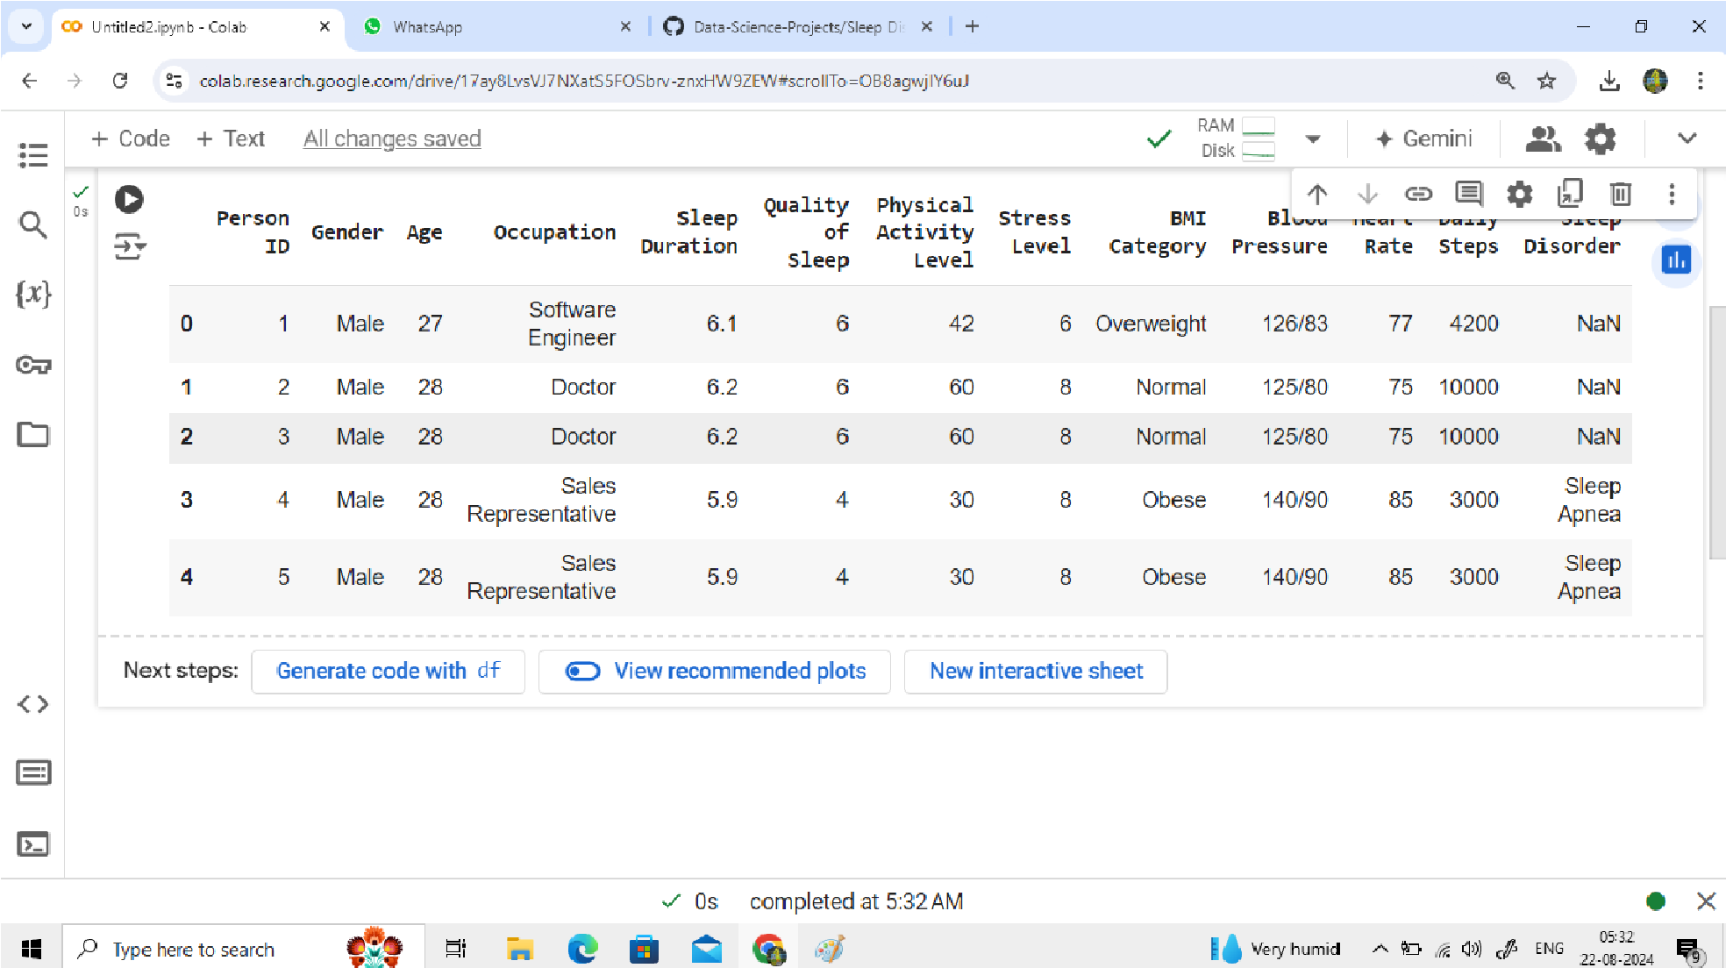

*FIG A1: Import And Reads A CSV File*

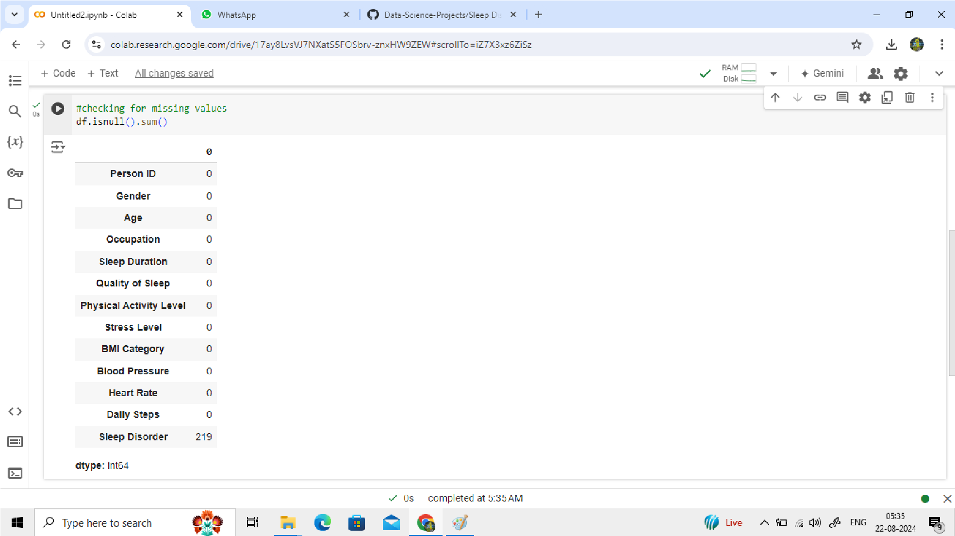

*FIG A2: Checking For Missing Values*

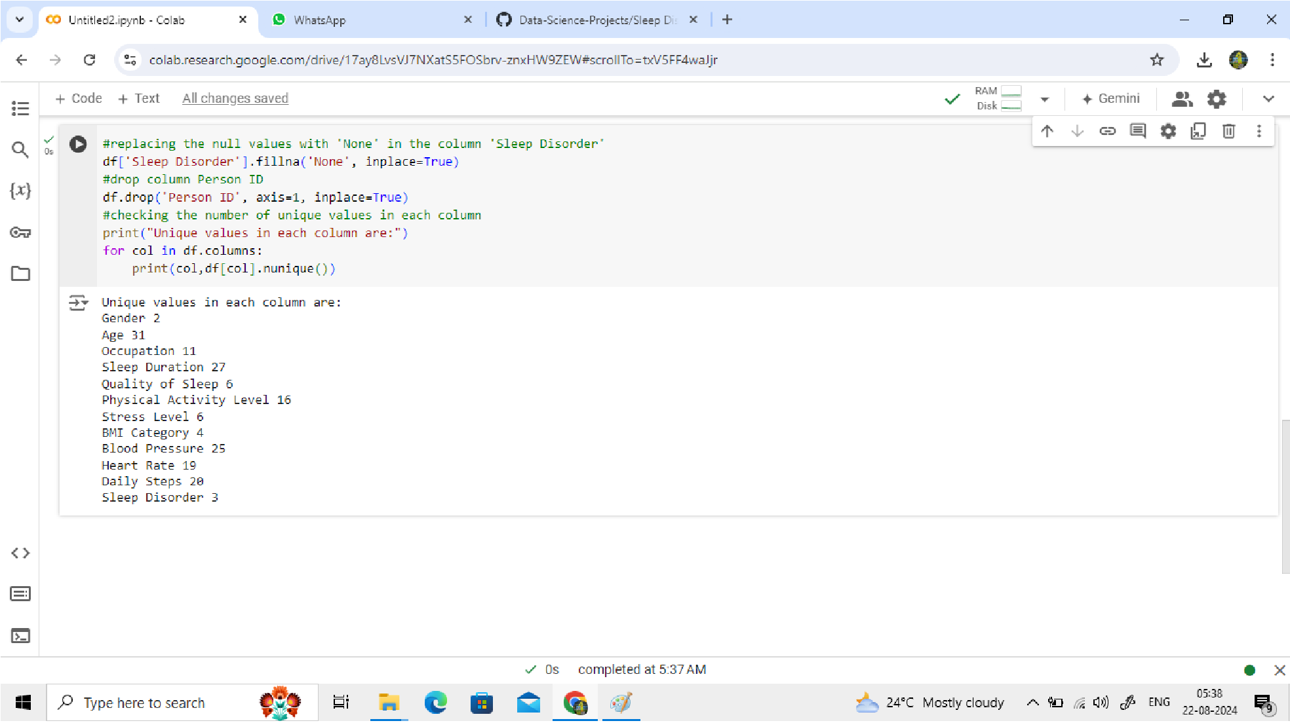

*FIG A3: Checking The Number Of Unique Values In Each Column*

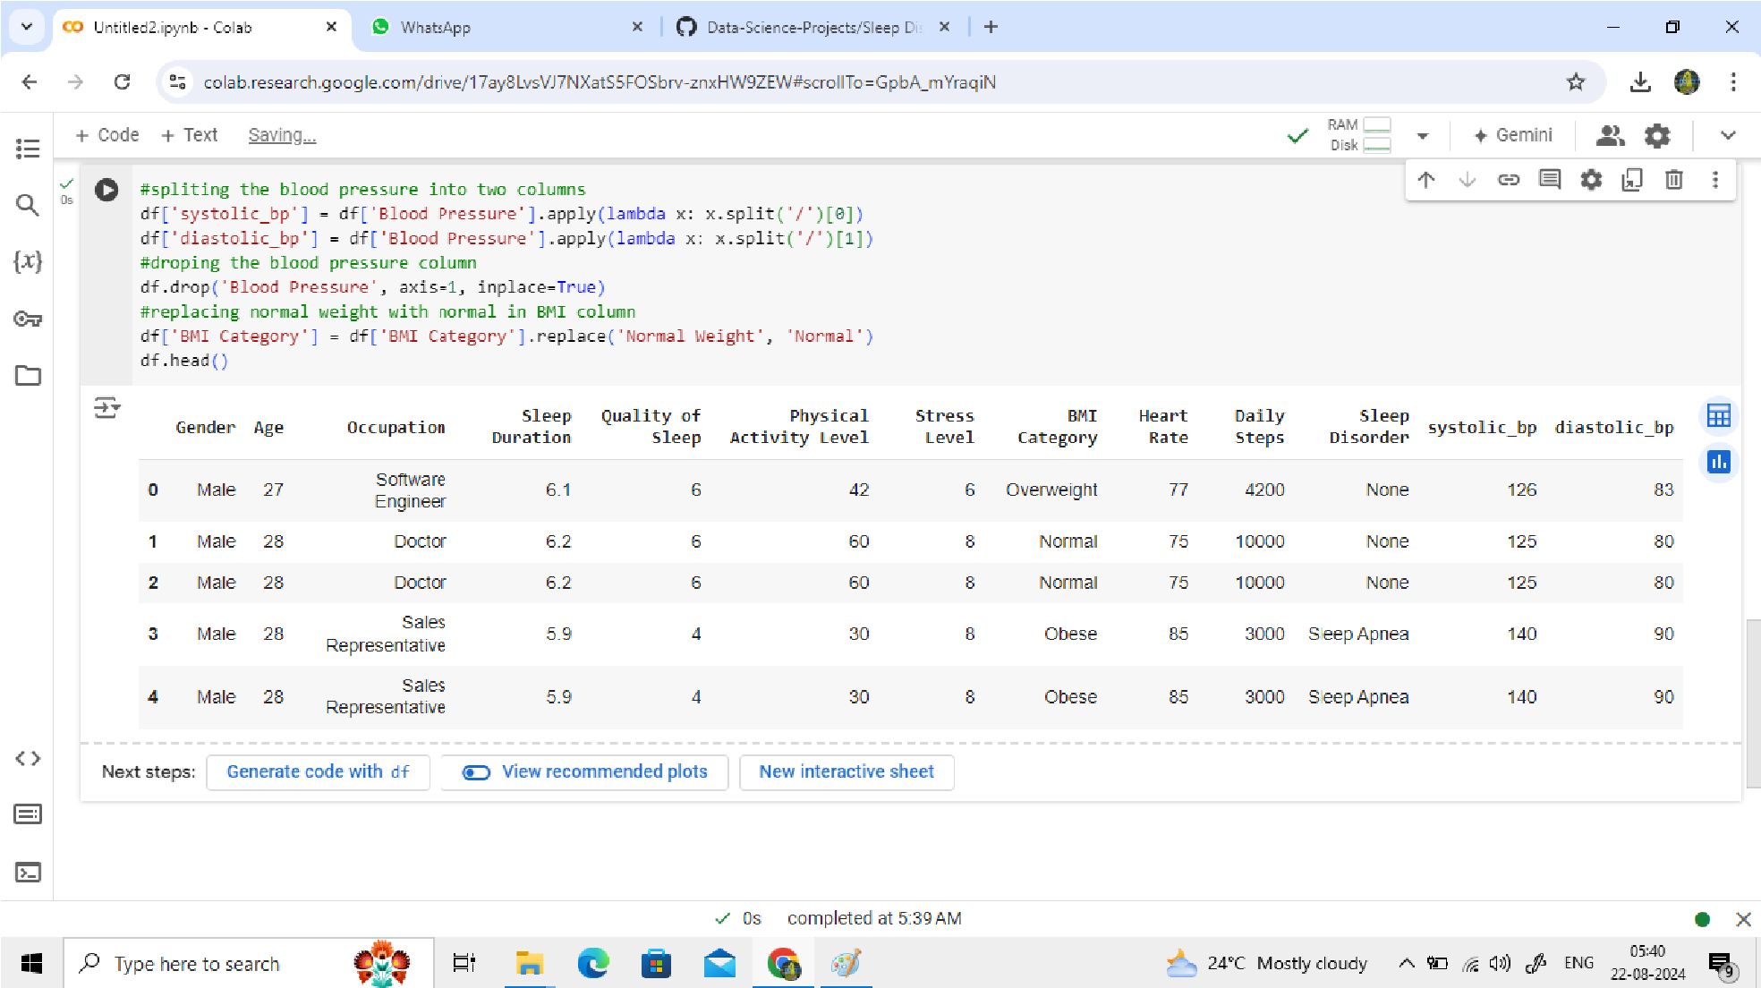

*FIG A4: splitting blood pressure into two columns, dropping the blood pressure column and replacing normal weight with normal in BMI column*

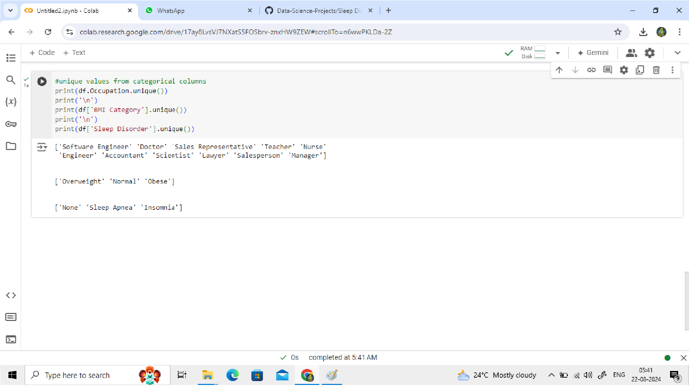

*FIG A5: Unique Values From Categorical Columns*

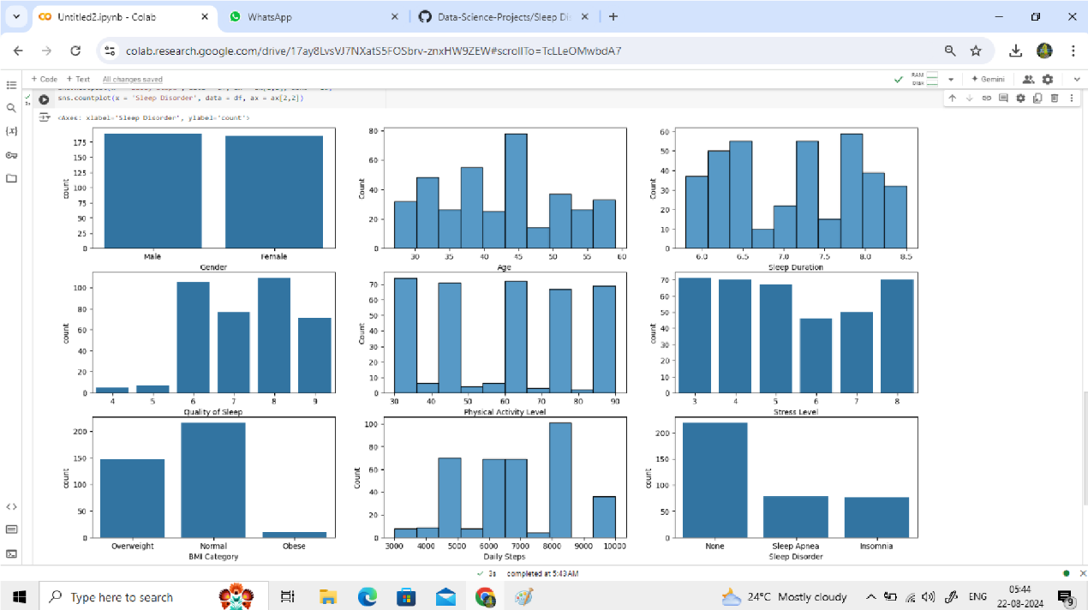

*FIG A6: Understanding The Data By Plotting Its Variables*

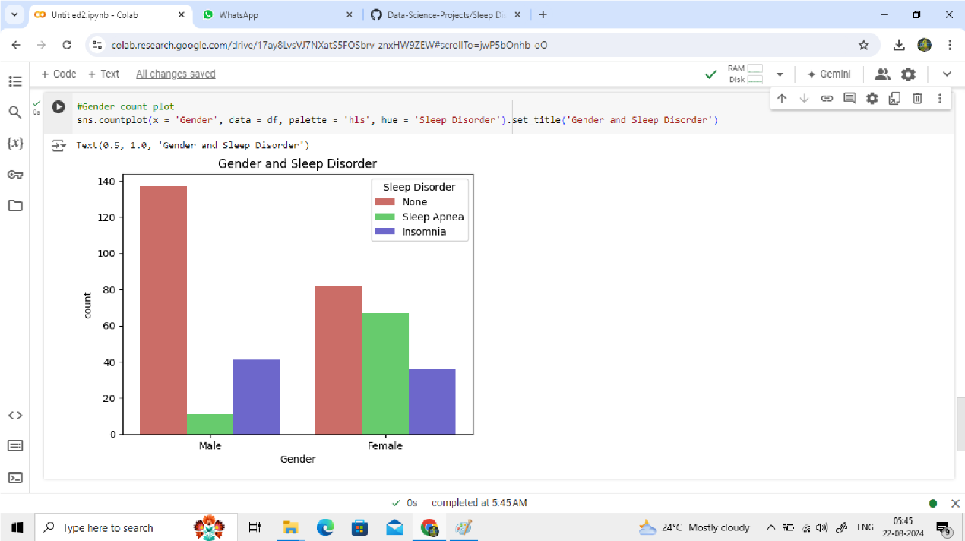

*FIG A7: Gender And Sleep Disorder*

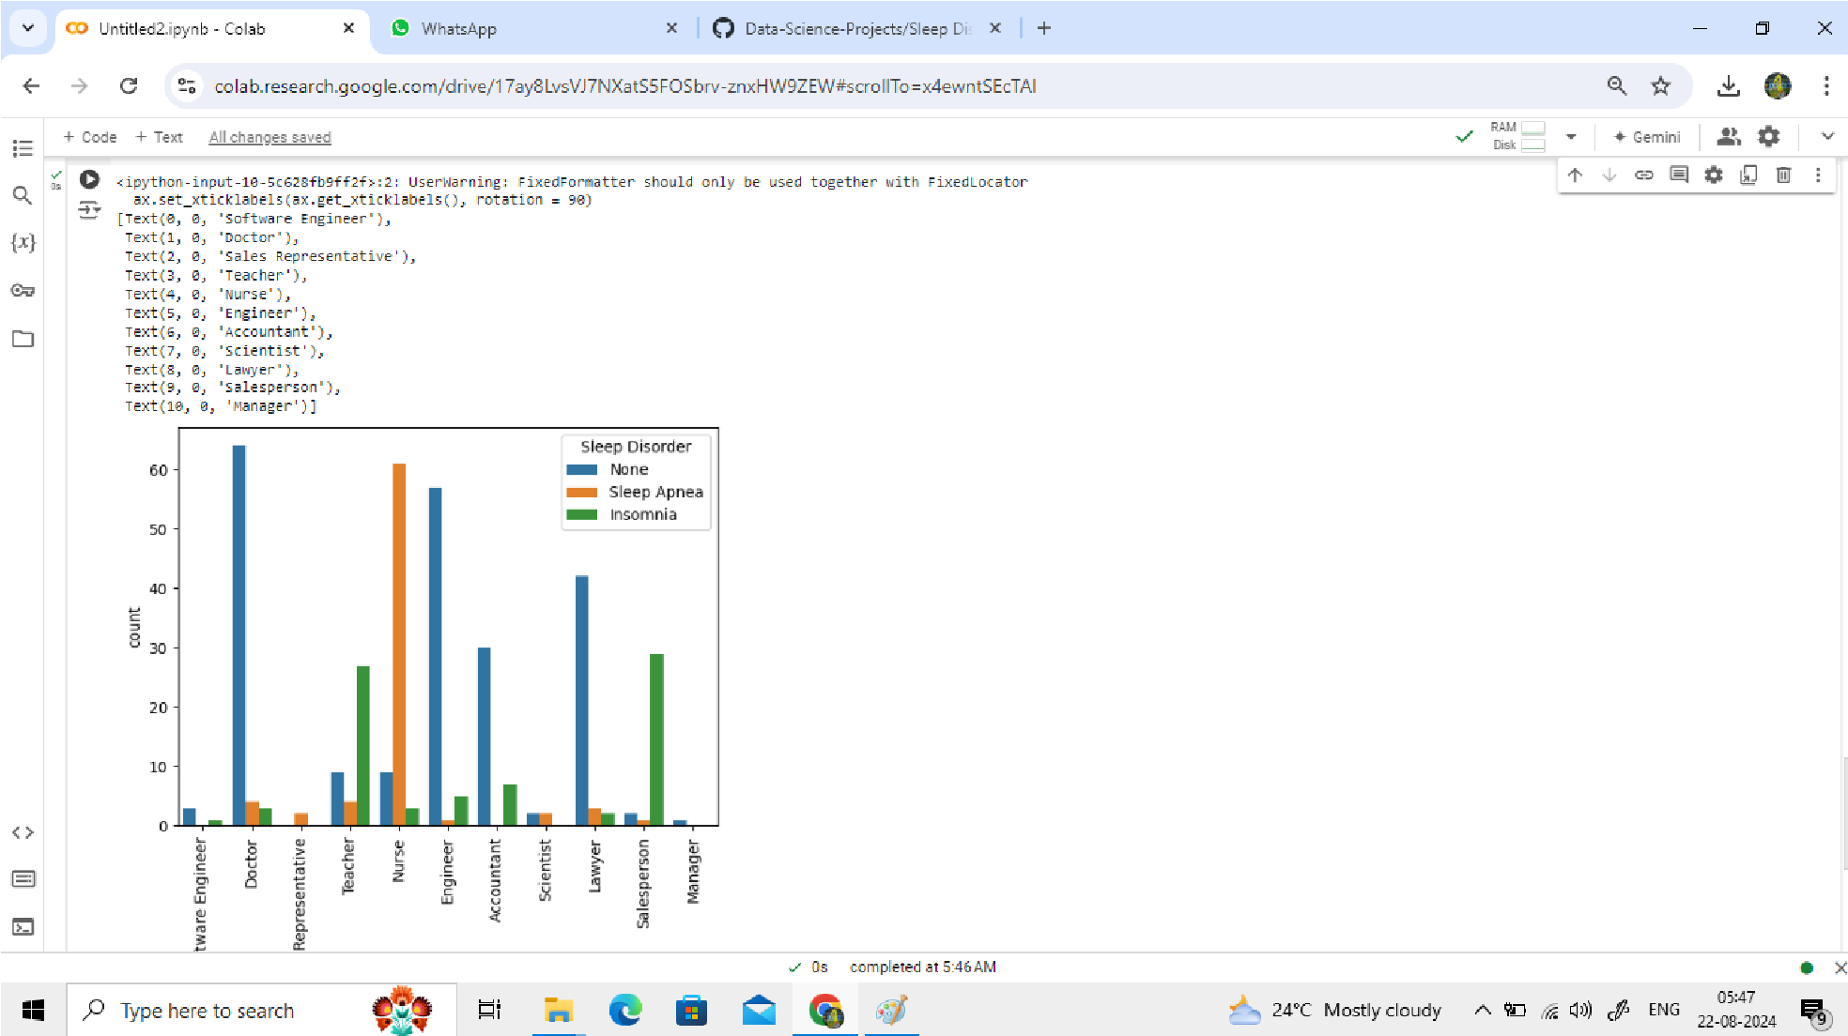

*FIG A8: Effect Of Occupation On Sleep Disorder*

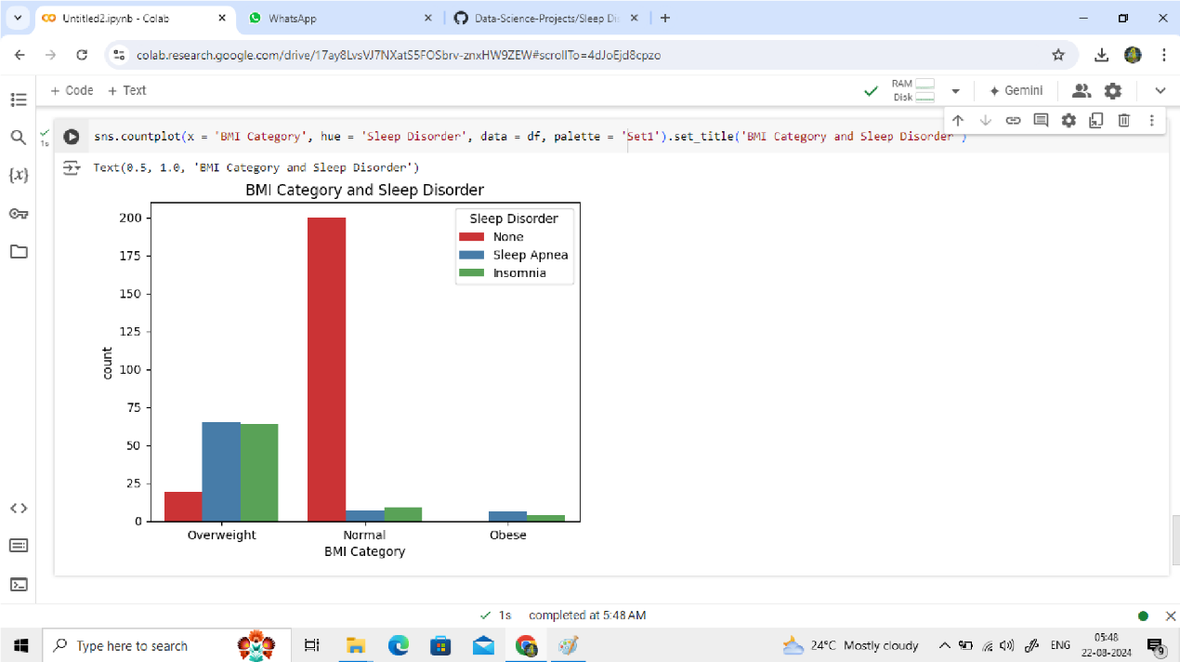

*FIG A9: BMI Category And Sleep Disorder*

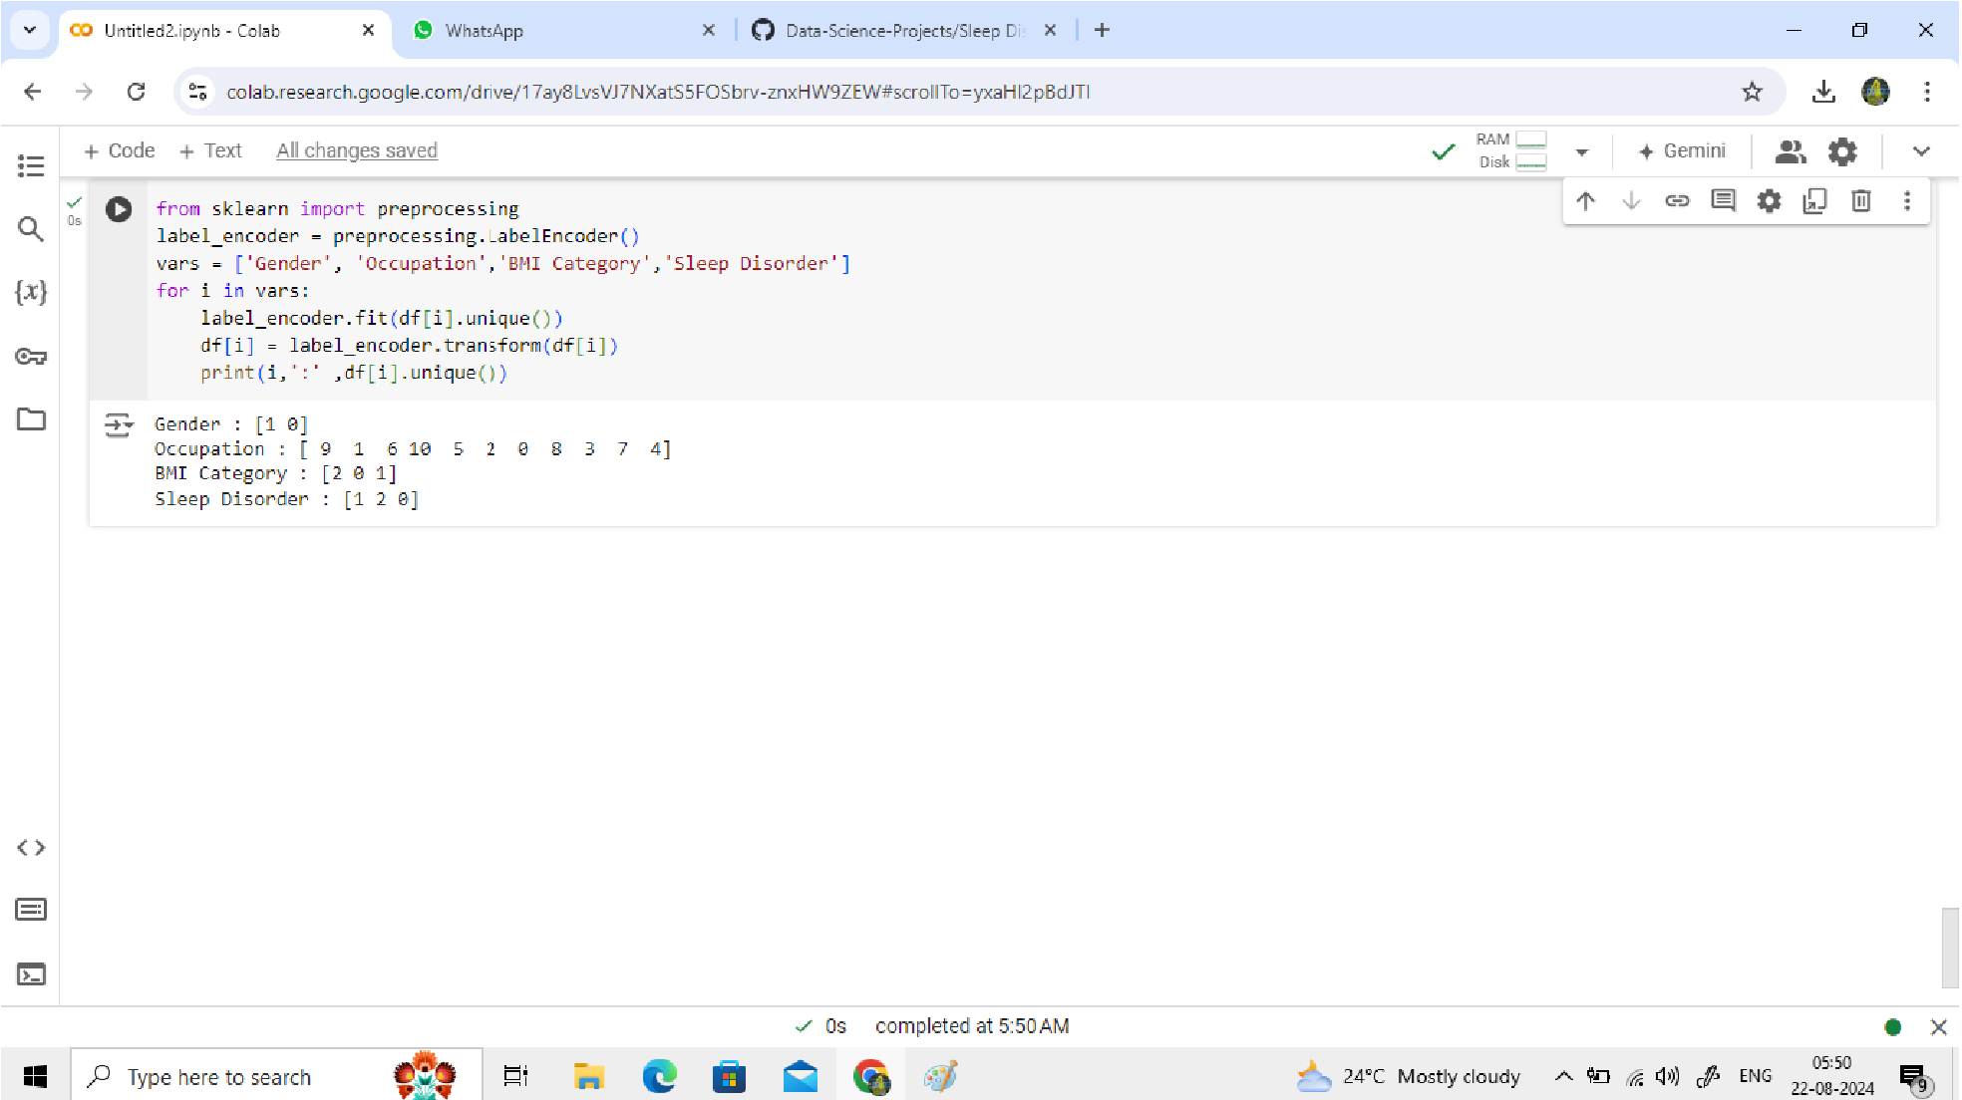

*FIG A10: Label Encoding For Categorical Variables*

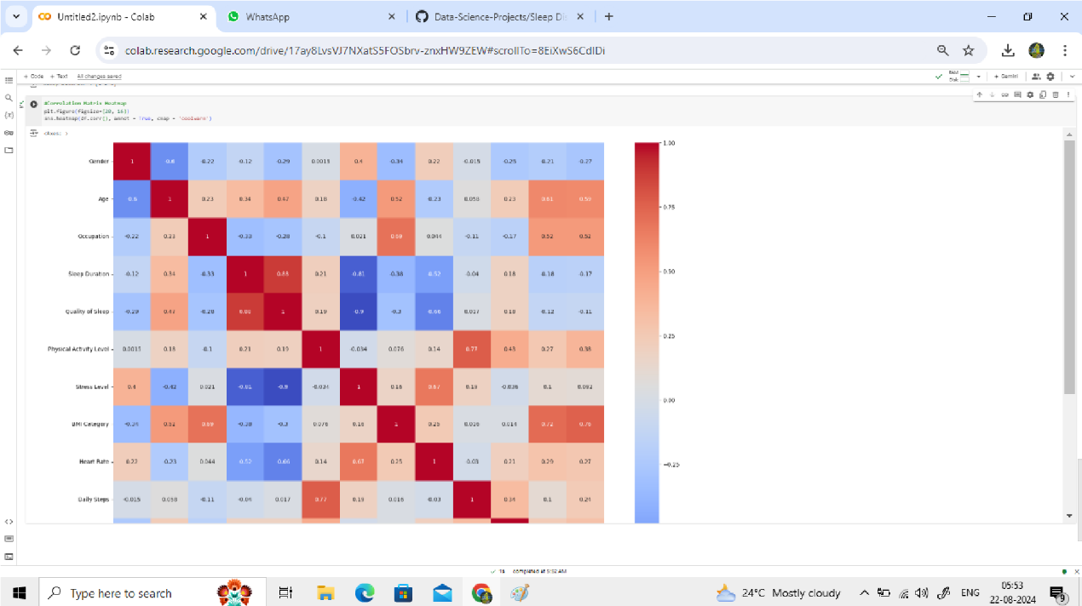

*FIG A11: Correlation Matrix Heatmap*

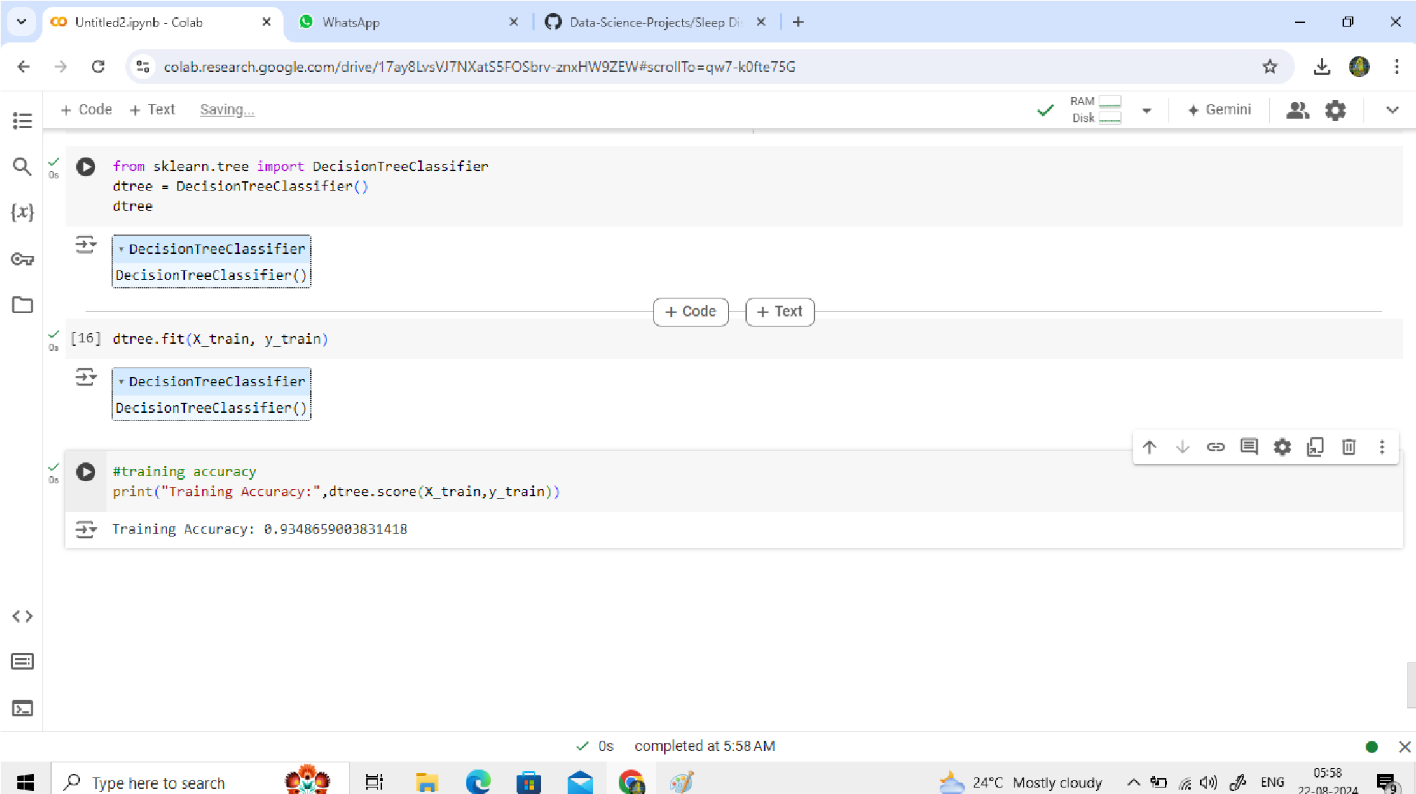

*FIG A12: Implementing Decision Tree And Training Accuracy*

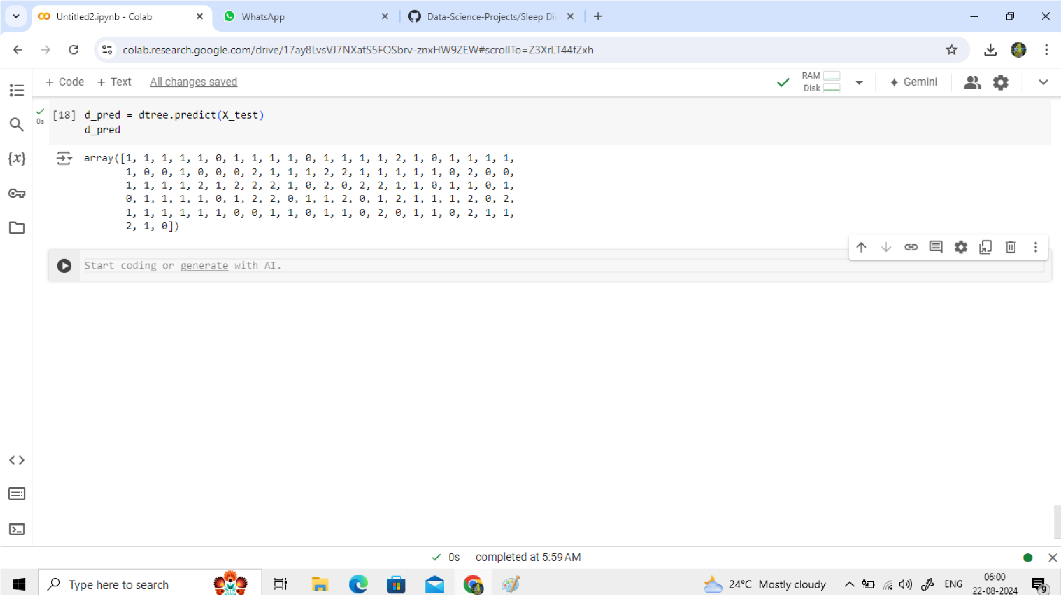

*FIG A13: Decision Tree Model Evaluation*

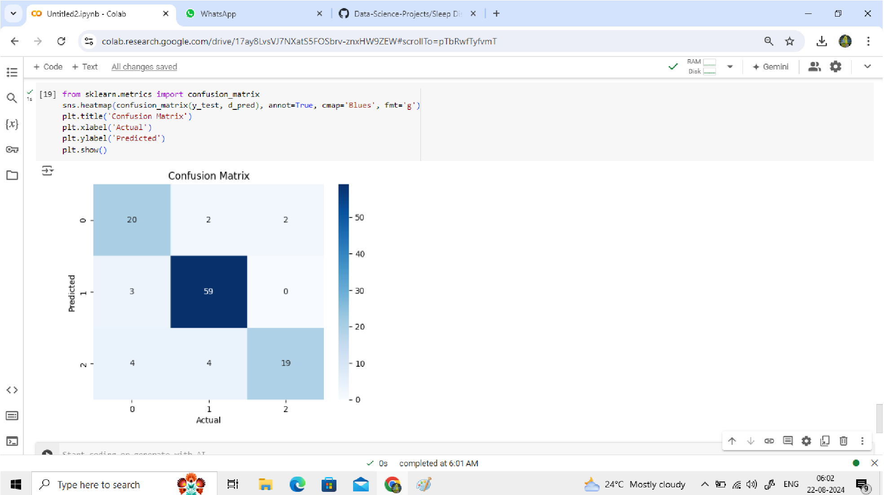

*FIG A14: Confusion Matrix*

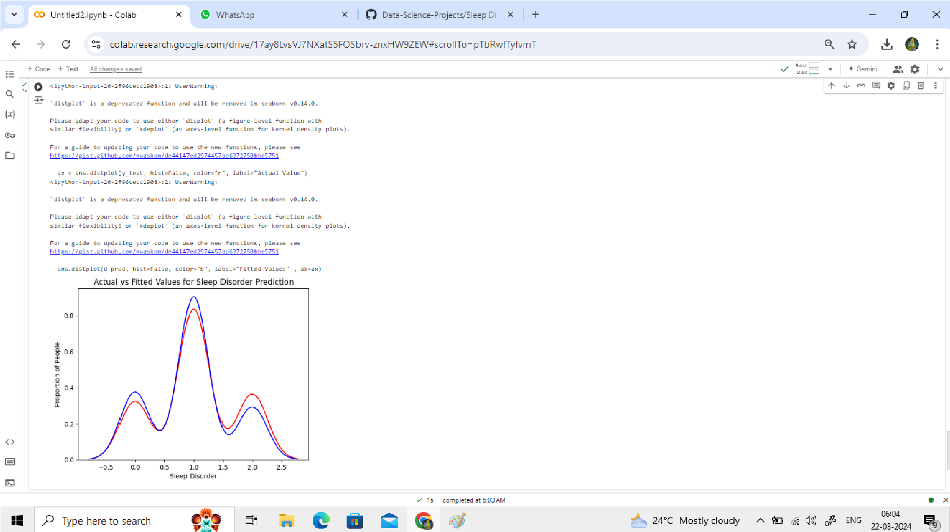

*FIG A15: Actual Vs Fitted Values For Sleep Disorder Prediction*

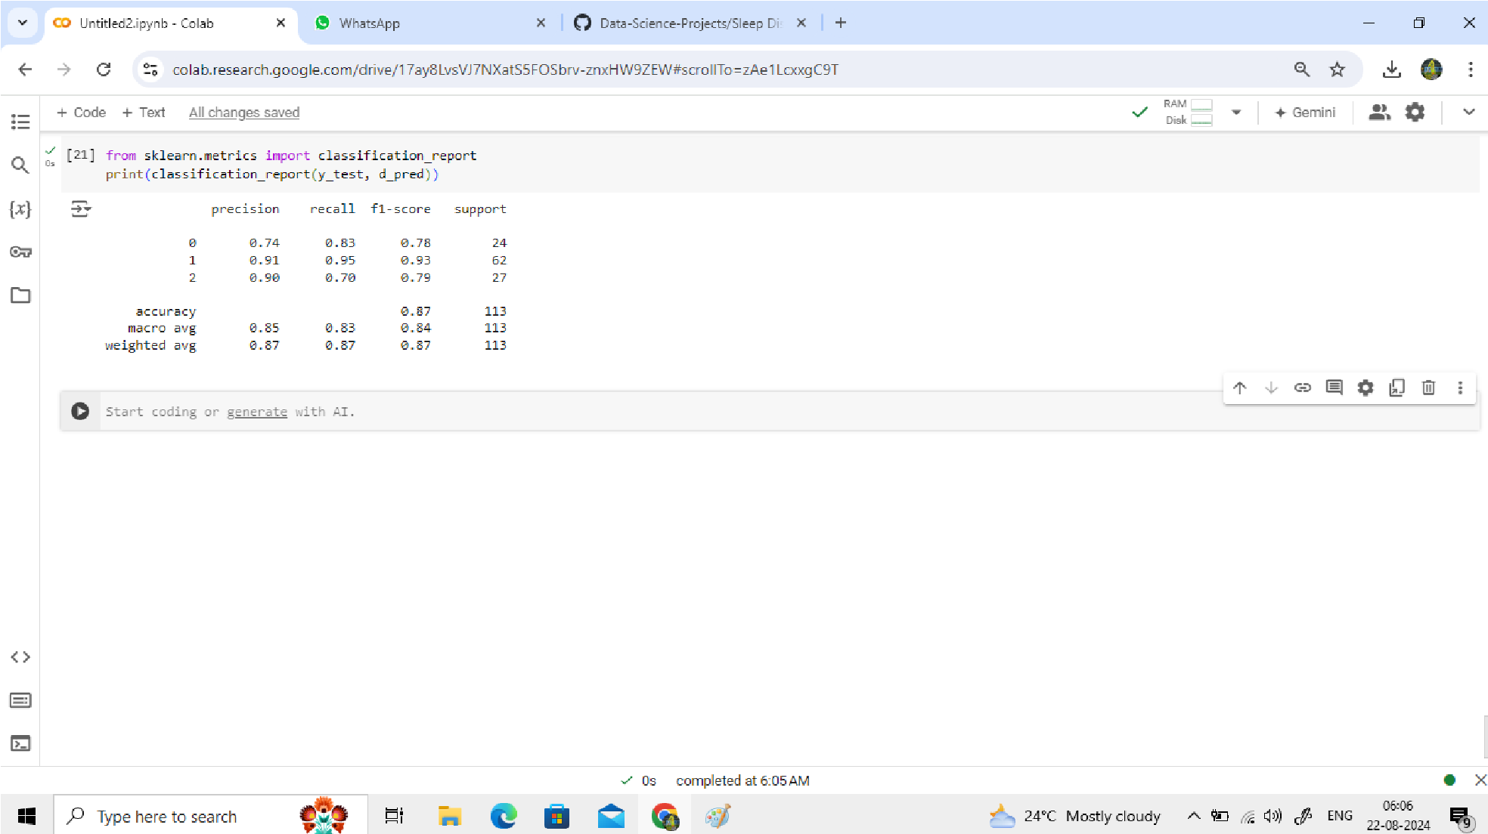

*FIG A16: Classification Report*

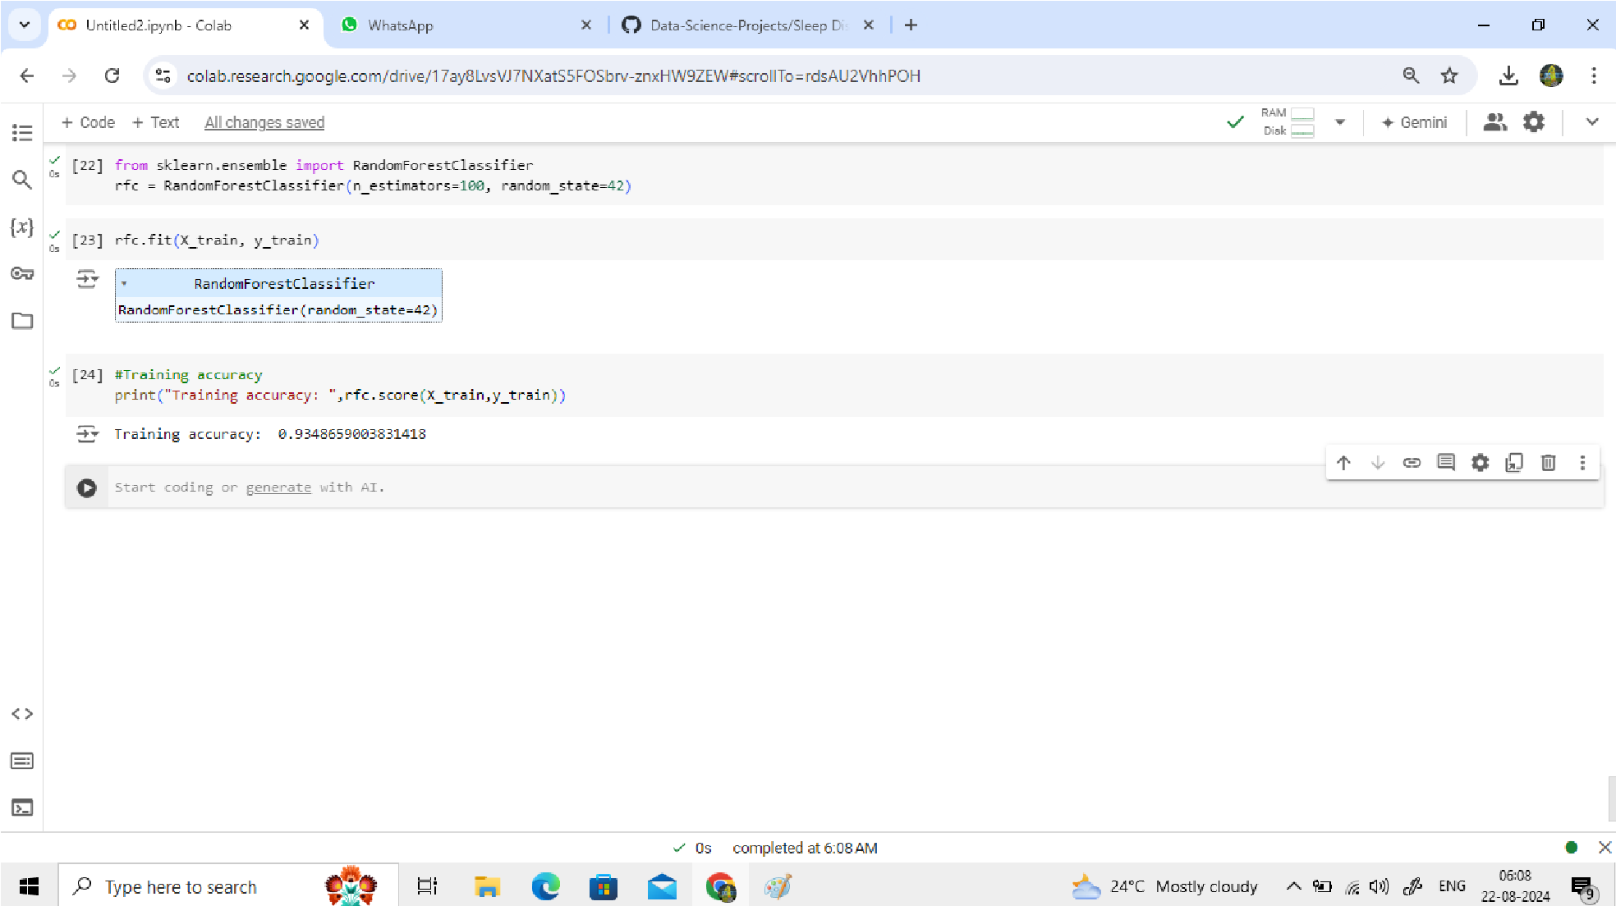

*FIG.A17: Random Forest Classifier And Training Accuracy*

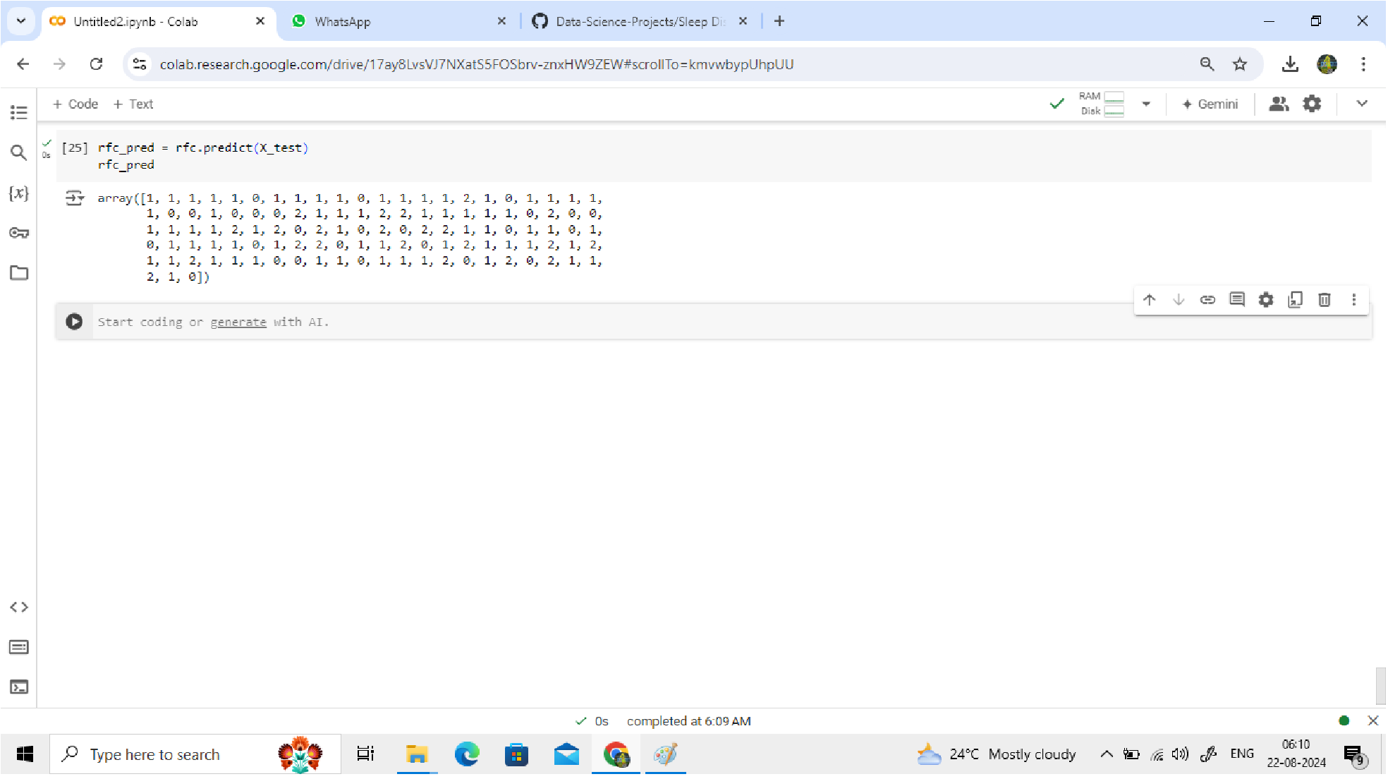

*FIG A18: Random Forest Classifier Evaluation*

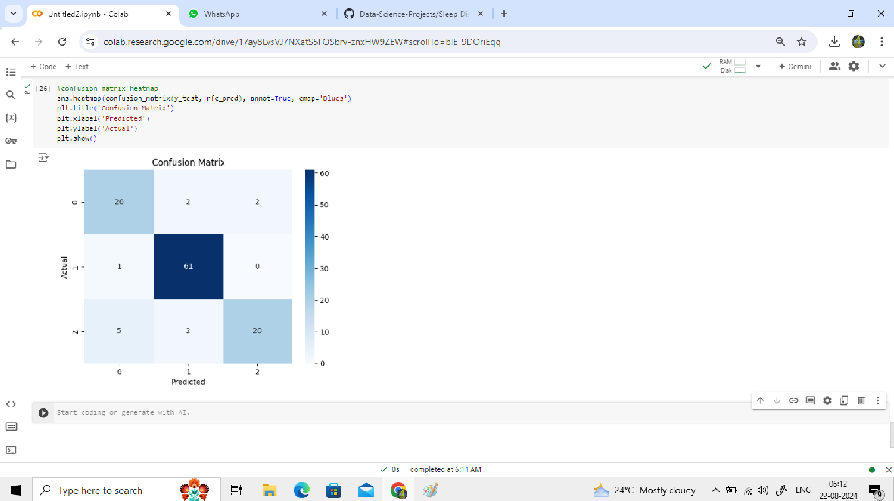

*FIG A19: Confusion Matrix Heatmap*

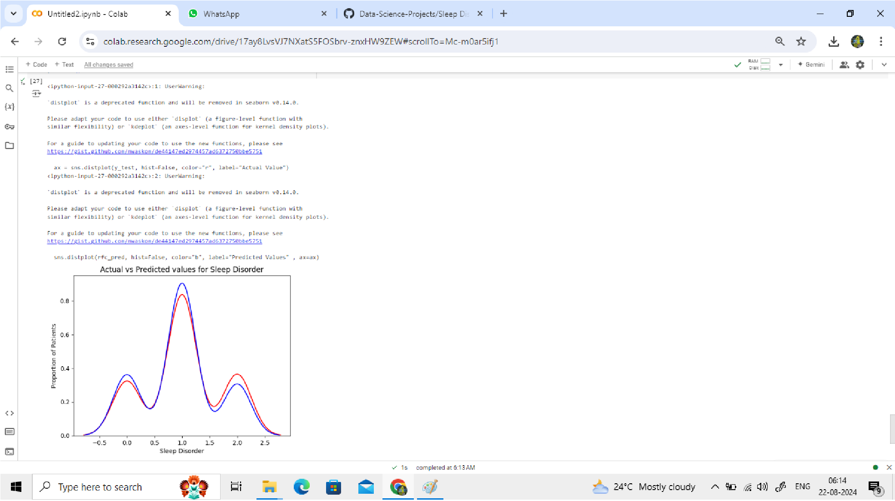

*FIG A20: Distribution Plot For Predicted And Acutal Values*

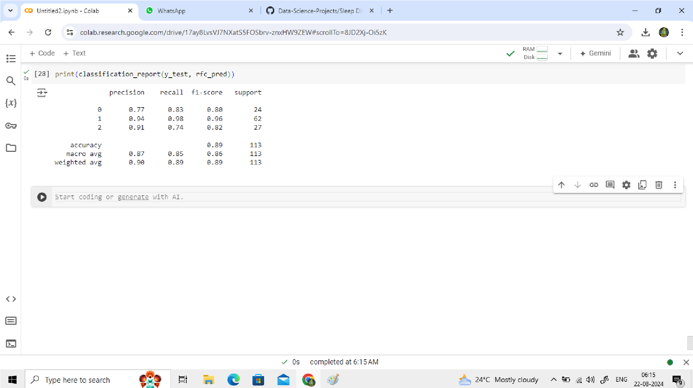

*FIG A21: Classification Report*

**APPENDIX II**

**A2.1 Bibliography and References**

1. **Buysse, D. J. (2014).** “Sleep Health: Can We Define It? Does It Matter? Sleep.” 37(1), 9-17 - A key paper discussing the importance of defining and measuring sleep health, relevant to understanding sleep disorders.
2. **Dean, D. A., Goldberger, A. L., Mueller, R., Kim, M., Rueschman, M., Mobley, D., Sahoo, S. S., Jayapandian, C. P., Cui, L., Zhang, G. Q., & Redline, S.(2016).** ”Scaling Up Scientific Discovery in Sleep Medicine: The National Sleep Research Resource. Sleep.” 39(5), 1151-1164 - Provides insights into large-scale sleep data collection and the challenges involved, useful for designing data collection modules.
3. **Géron, A. (2019**). “Hands-On Machine Learning with Scikit-Learn, Keras, and TensorFlow: Concepts, Tools, and Techniques to Build Intelligent Systems. O'Reilly Media.”- A practical guide to machine learning, covering tools and techniques that are essential for building and deploying sleep disorder prediction models.
4. **Goldstein, C. A., & Shapiro, C. M.(2018).”** The Role of Wearable Devices in Sleep Disorder Diagnosis and Treatment. Sleep Medicine Clinics.” 13(2), 245-256.- Discusses the use of wearable technology in diagnosing and treating sleep disorders, relevant to the data collection aspect of the project.
5. **Zhang, Z., Pi, Z., & Liu, B.** **(2015).”** Machine Learning in Predicting Sleep Disorders: Challenges and Opportunities. Computational and Structural Biotechnology Journal.” 13, 58-66 - A paper discussing the challenges of using machine learning for sleep disorder prediction, providing context and insights into potential pitfalls and solutions.

## Bibliography

• <https://chatgpt.com/?model=auto>

• <https://www.geeksforgeeks.org/introduction-to-data-science/>

• <https://www.eraser.io/diagramgpt>

• <https://www.ibm.com/topics/data-science>

• <https://www.projectpro.io/projects/data-science-projects>